**CPU**

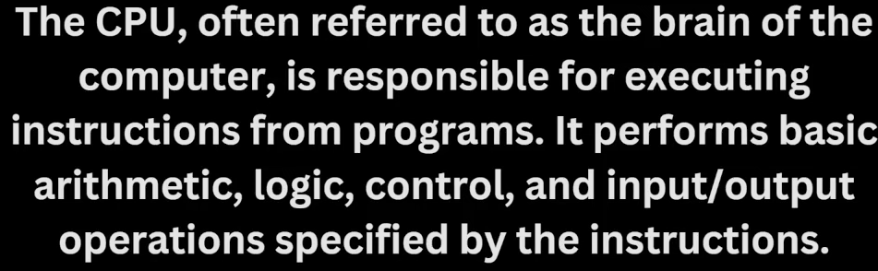

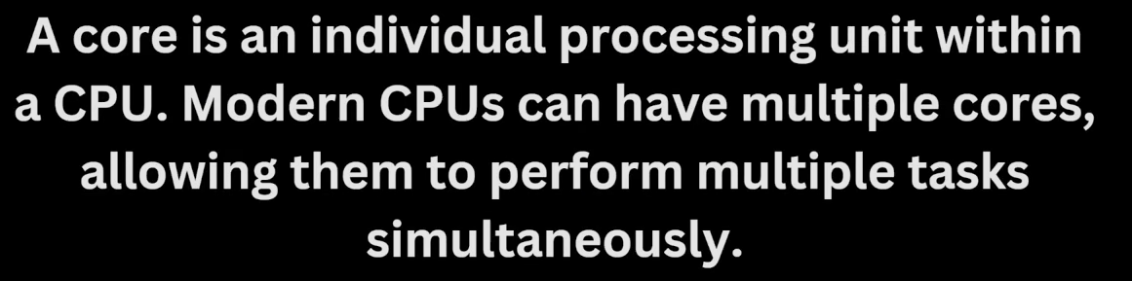

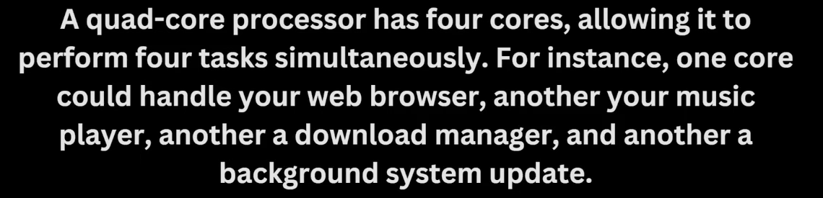

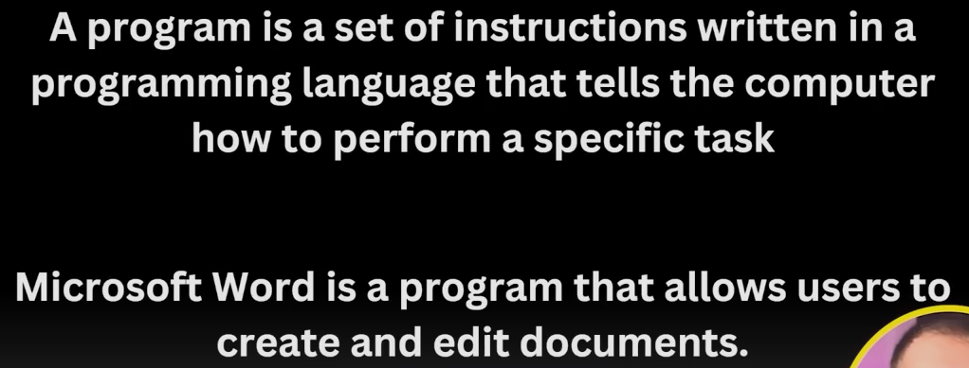

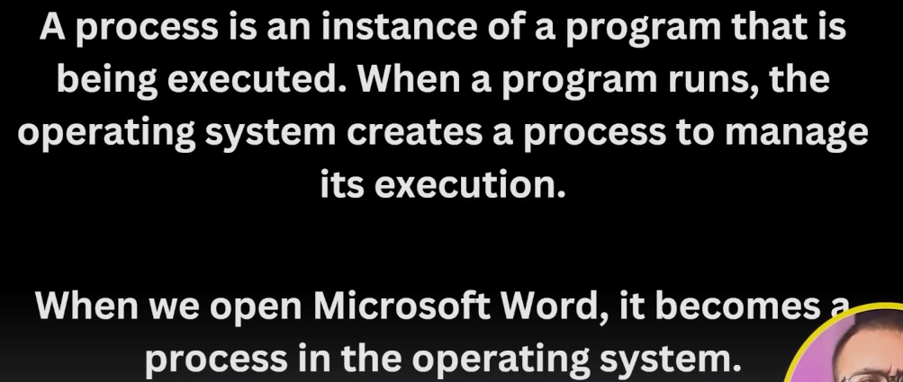

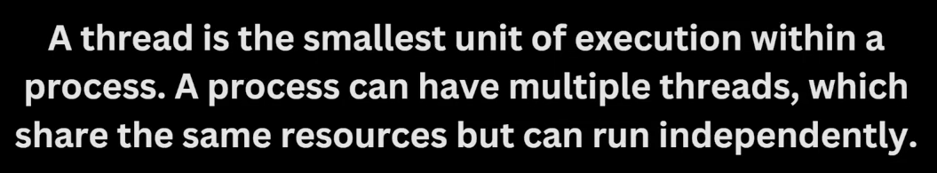

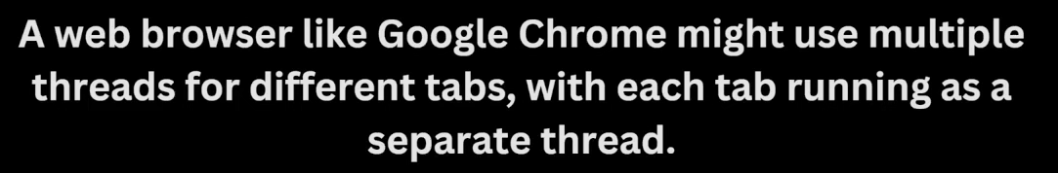

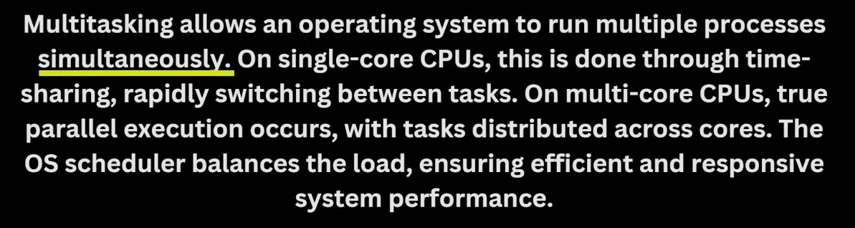



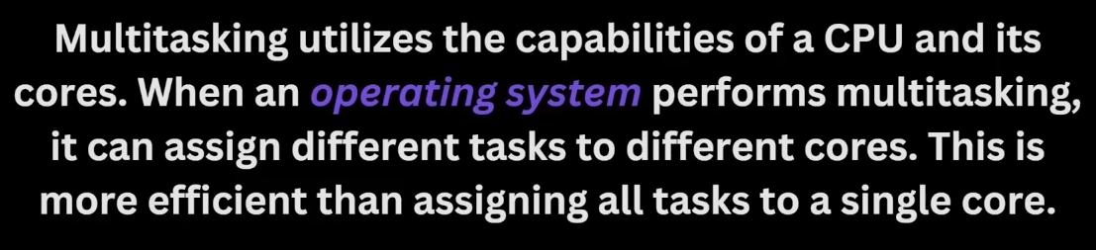

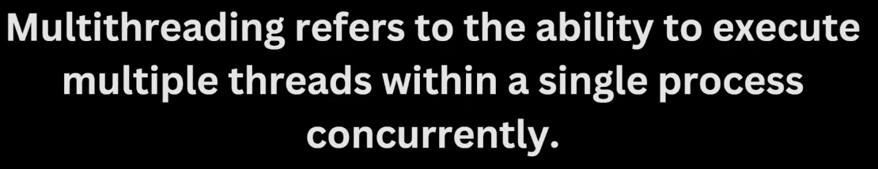

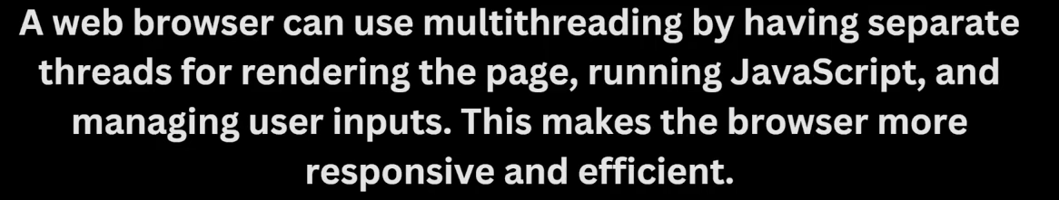

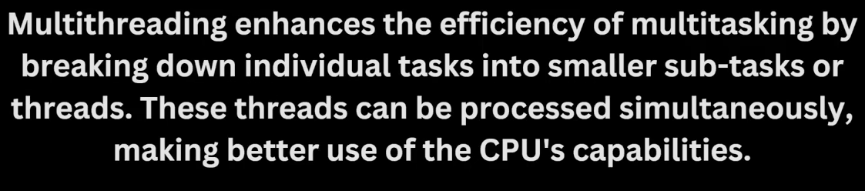

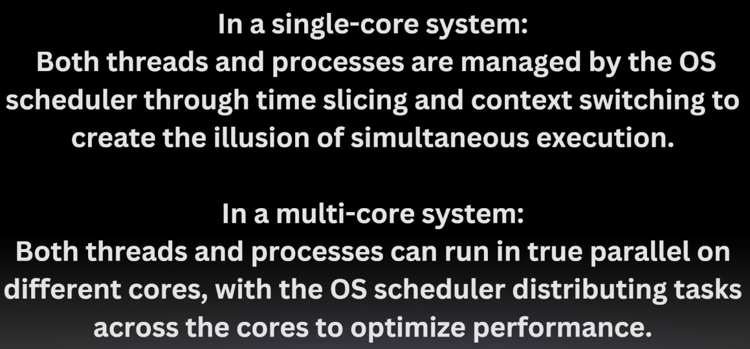

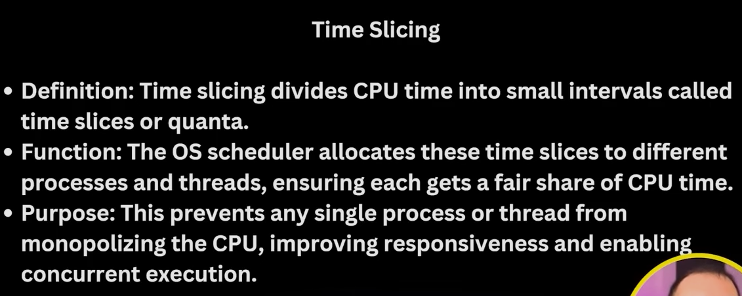

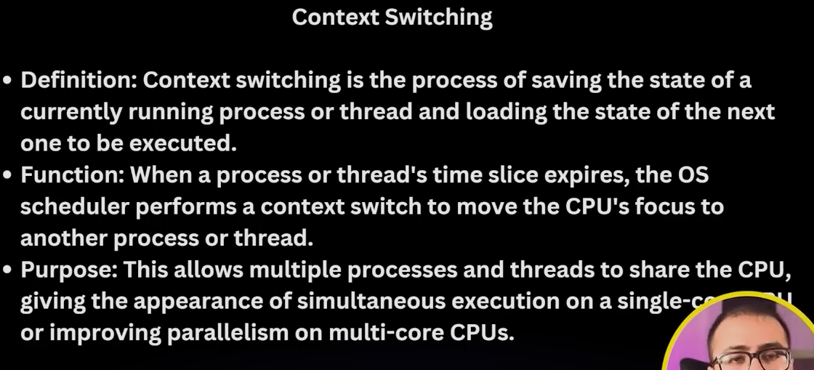

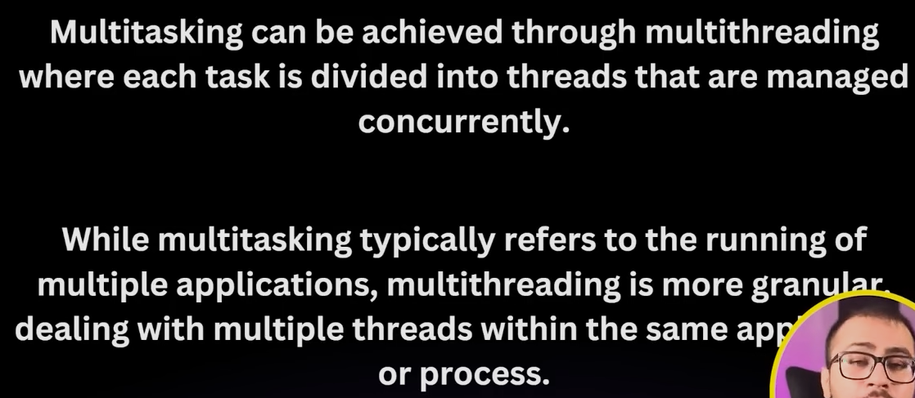

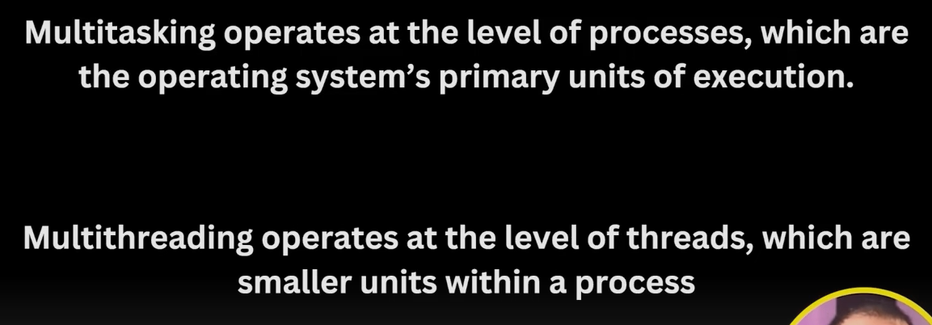

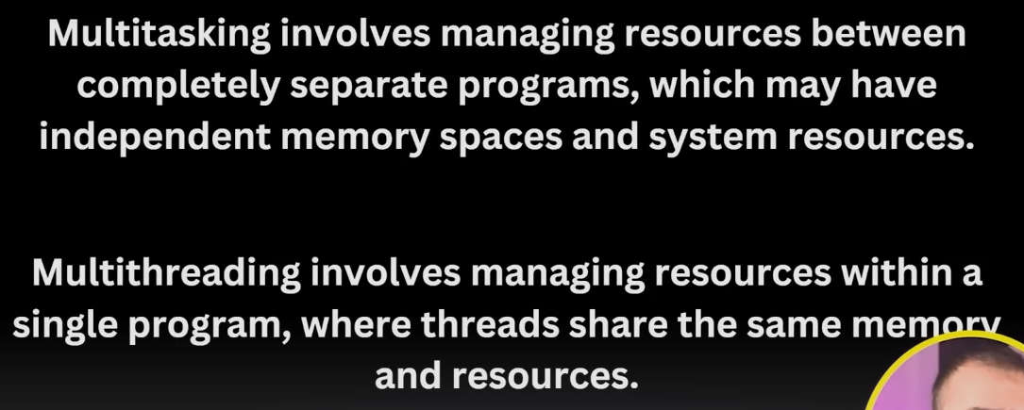

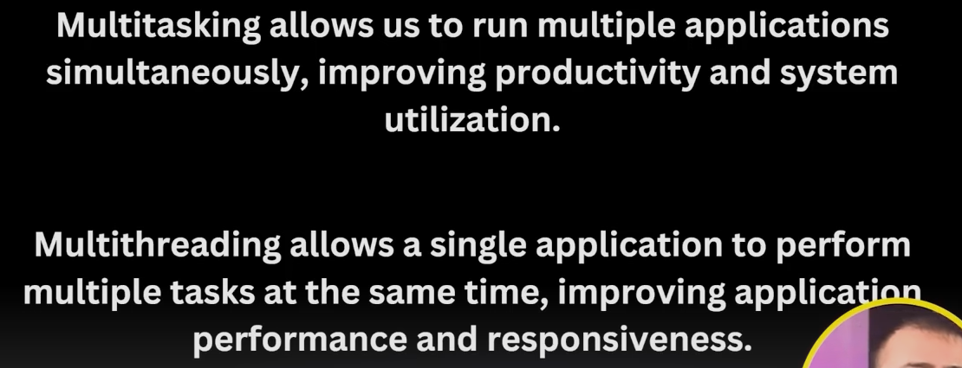

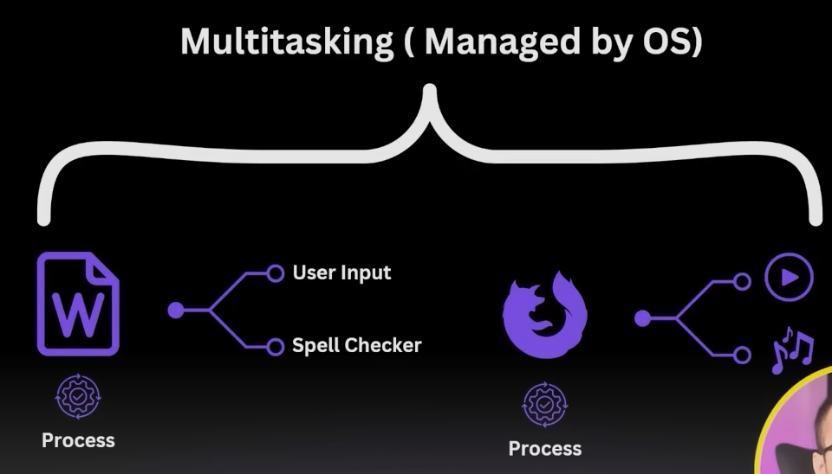

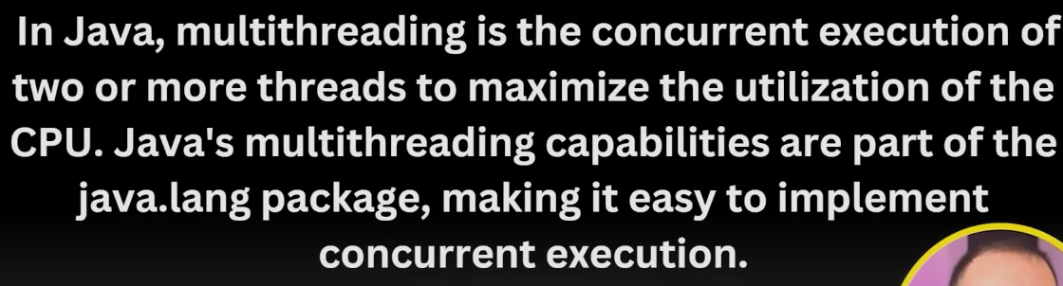

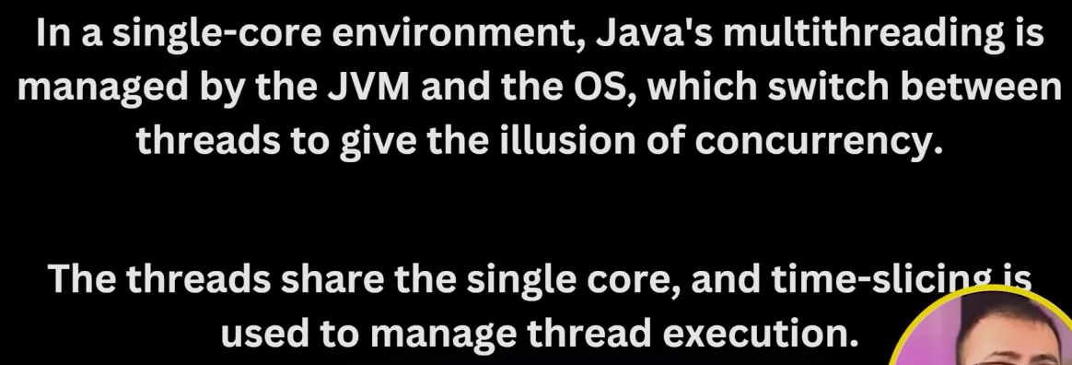

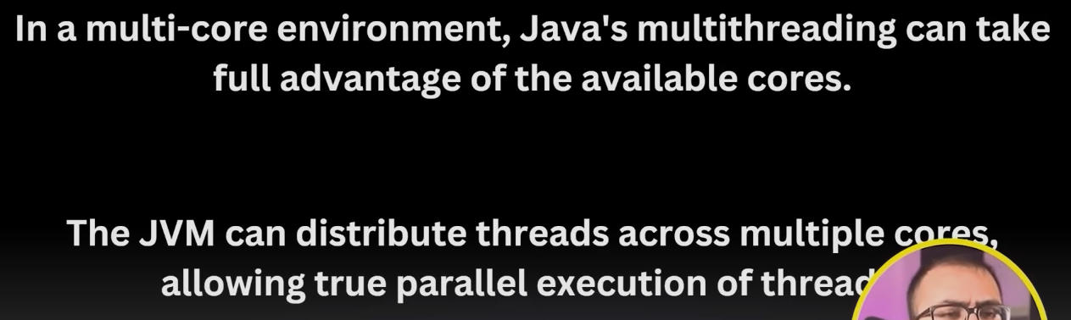

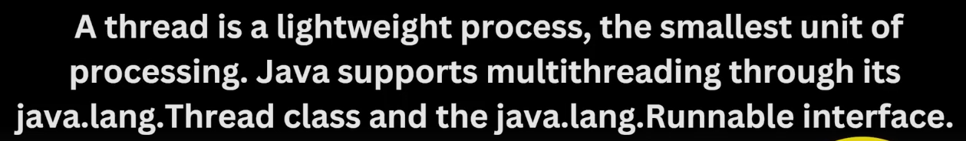

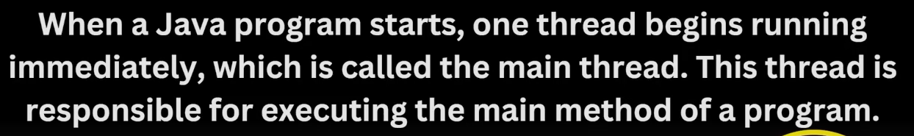

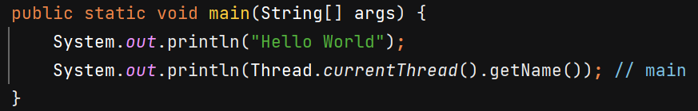

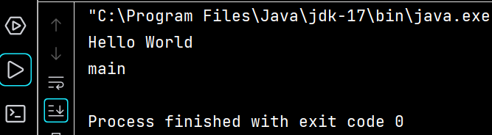



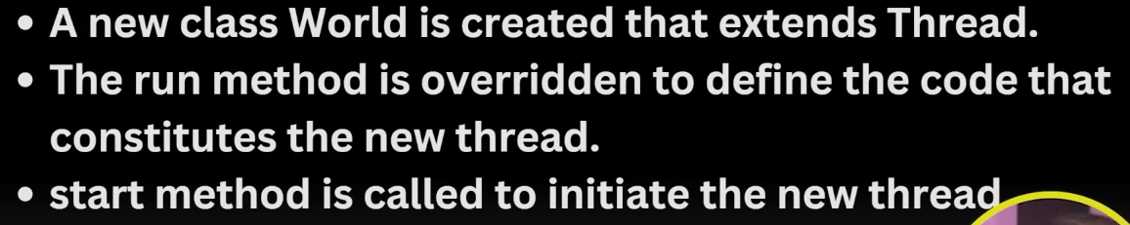

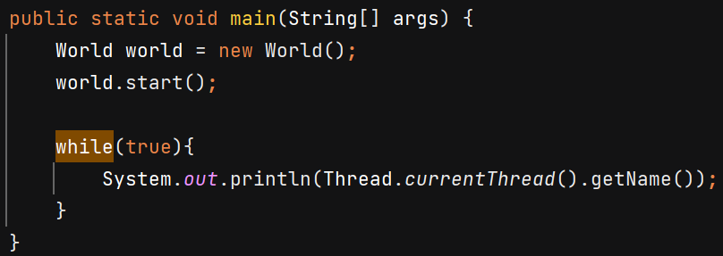

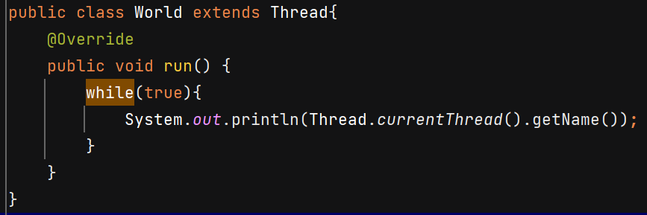

O/P - 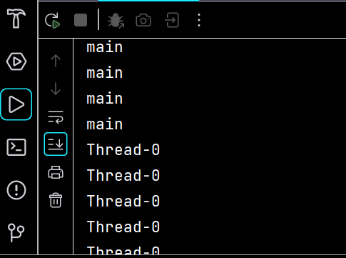

**Method 2** –

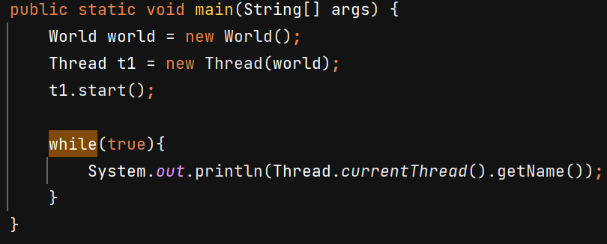

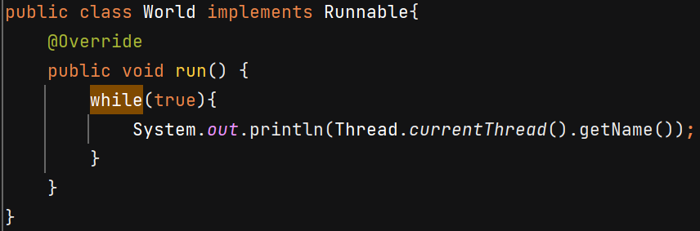

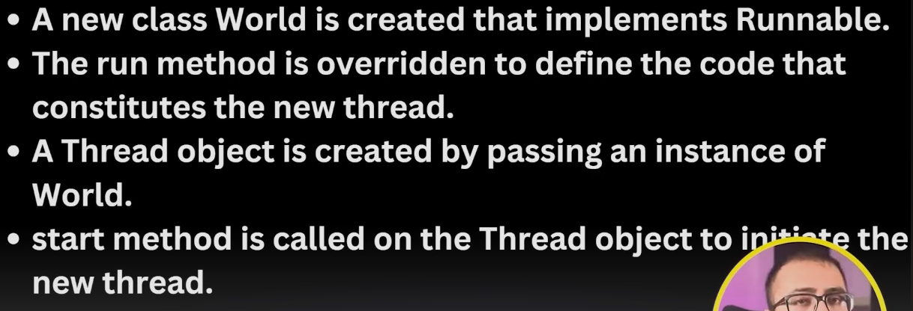



**Thread Lifecycle**

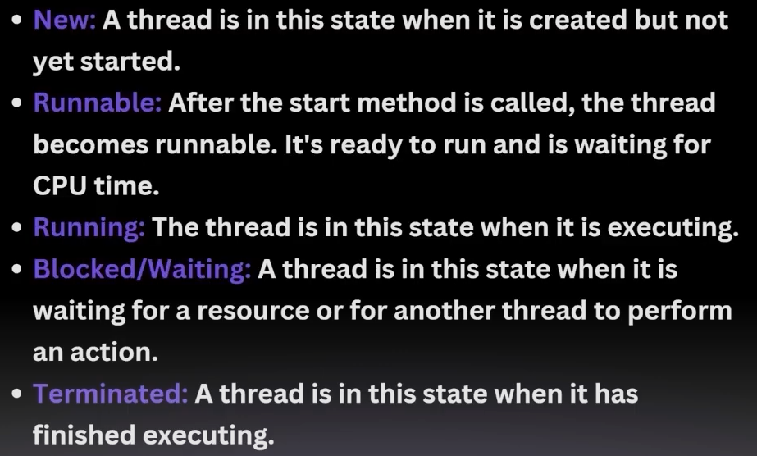

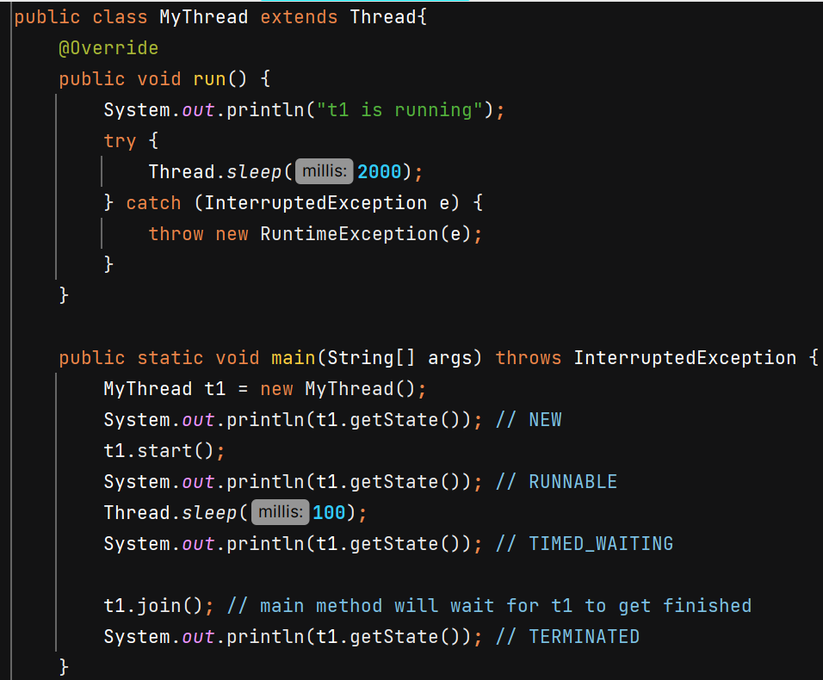

**Thread v/s Runnable**

Suppose class A already extends class B in that case we cannot extend it by Thread class also because multiple inheritance is now allowed, in this case class A should implement Runnable interface and override Run() method.

**Threads**

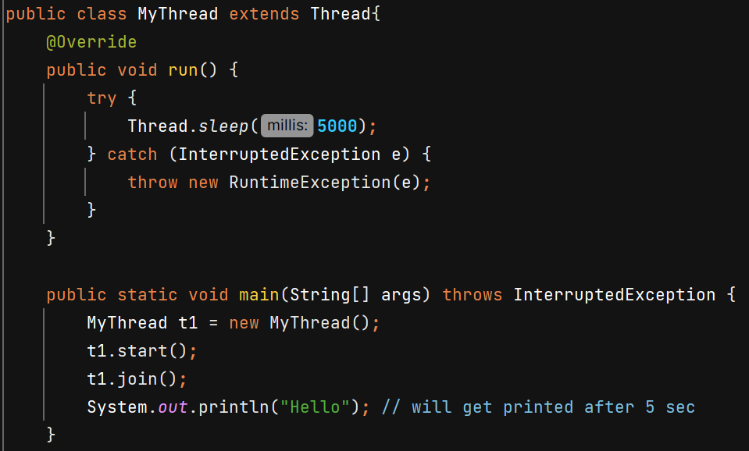

Methods –

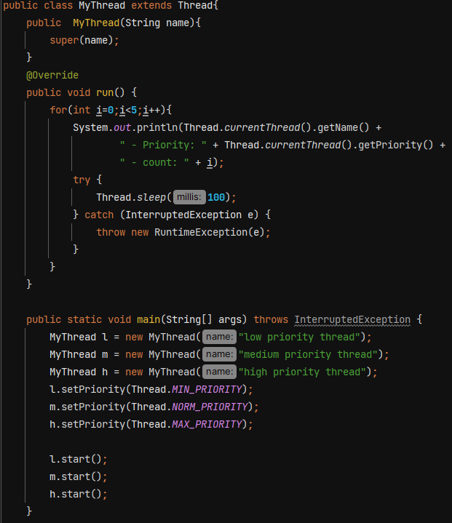

In constructor we can pass name of thread.

Using setPriority() we give hints to JVM about relativve im,portance of threads, it is not strictly followed. Maybe thread with low priority execute earlier than threat with medium priority.

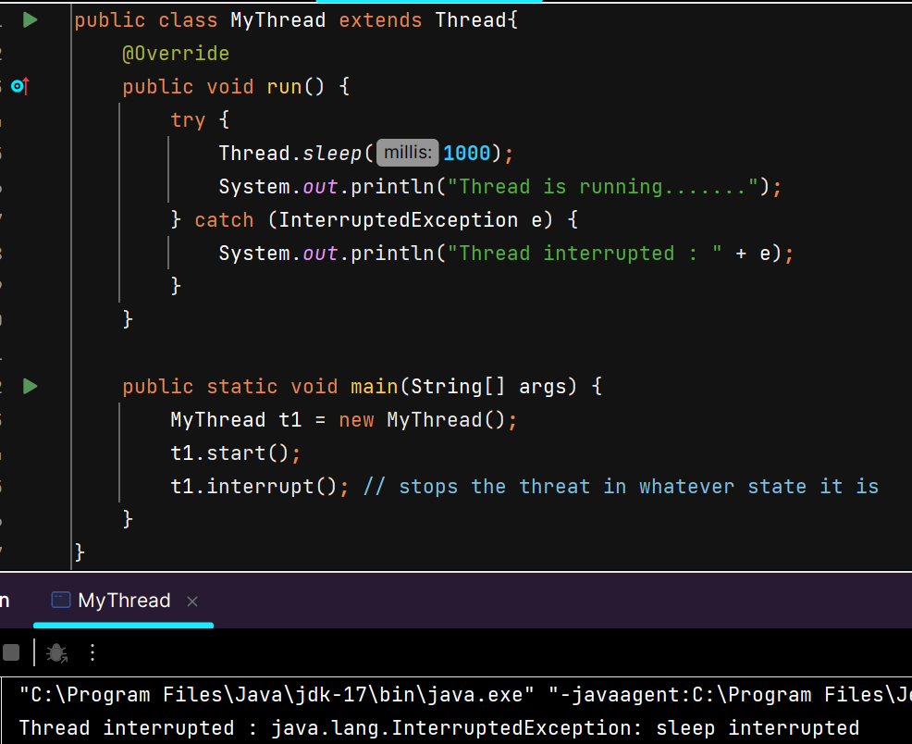

Yield() - A hint to the scheduler that the current thread is willing to yield its current use of a processor. The scheduler is free to ignore this hint.

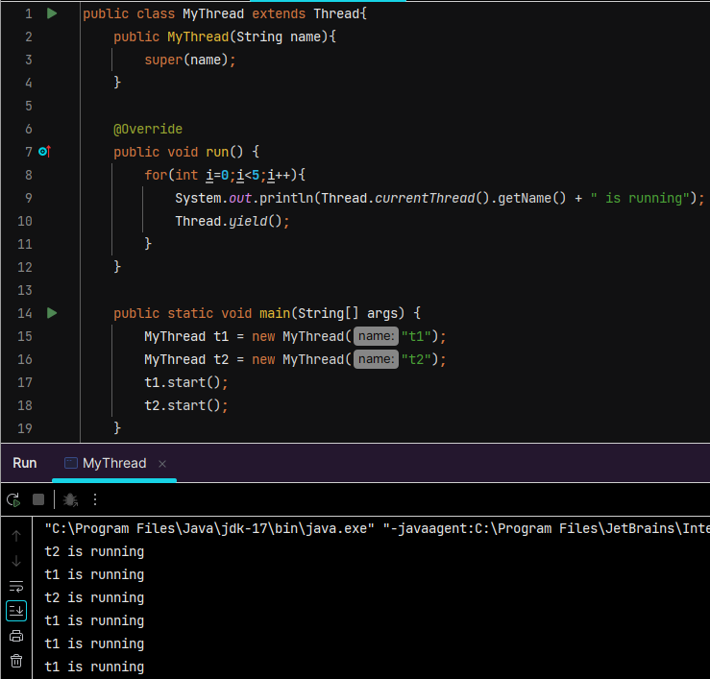

User Thread – whatever work we are performing inside run() are done with help of user threads.

Daemon Thread – they run in background. Ex- garbage collector in Java. JVM don’t wait for their execution to end. As soon as main thread, all other user threads are done, daemon threads are also terminated and JVM terminates.

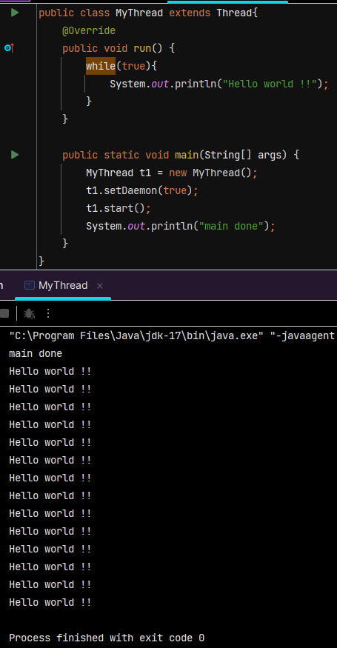

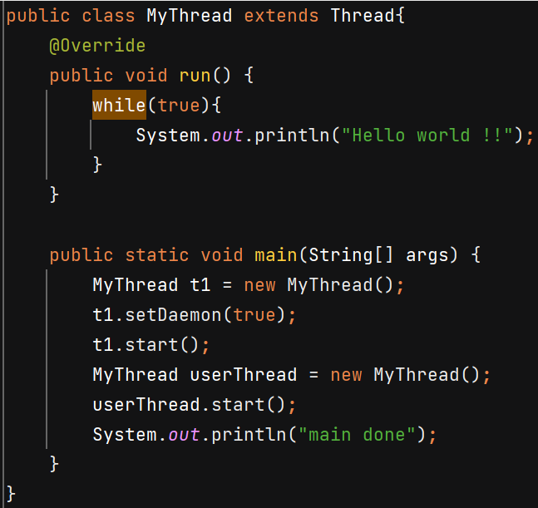In this case both threads keep running and JVM will wait for userThread to finish.

**Synchronization**

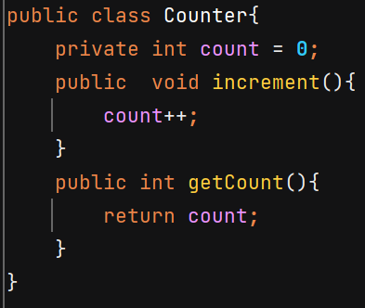 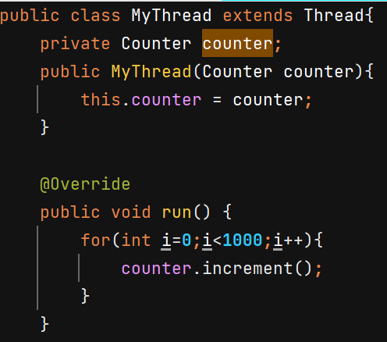

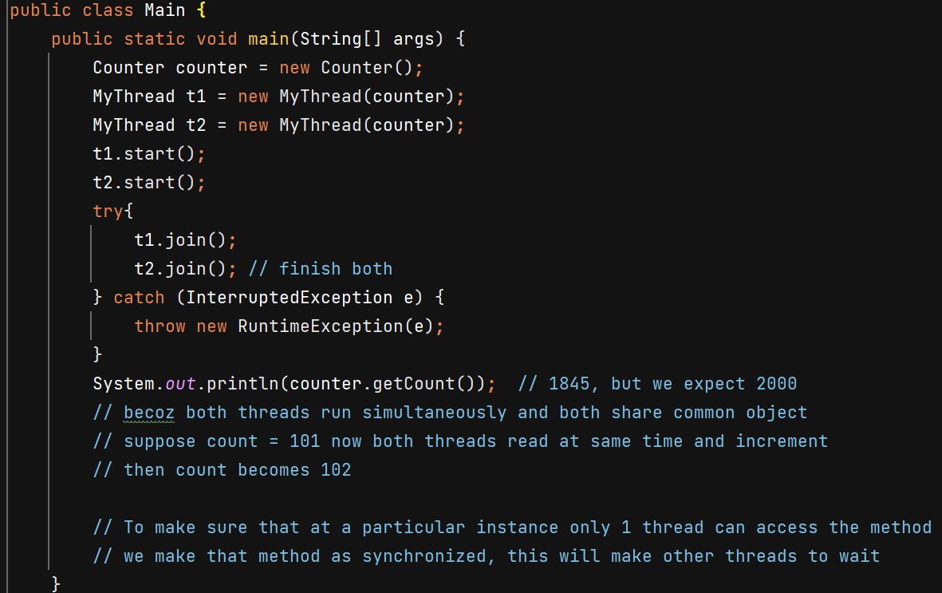

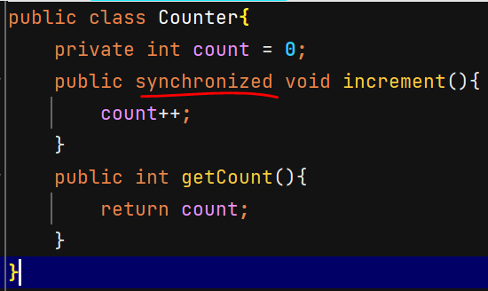 Now O/P – 2000

Instead of whole method we can make a particular block synchronized –

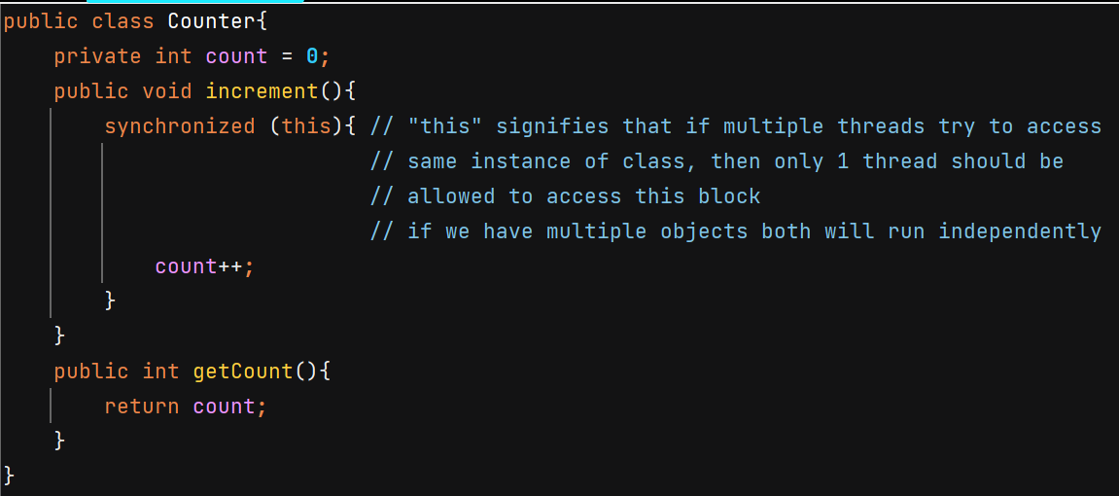

**Critical section** – Part of our code where shared resources are accessed and modified. Ex- increment() method in above example.

**Race Condition** – when multiple threads are working on shared resources and if their timing conflicts it can lead to unexpected results.

**Mutual Exclusion** – condition when only 1 thread can access the critical section

**Locks** – after using synchronized keyword on method we achieve mutual exclusion it is done by locking. When 1 thread is working on shared resource it puts lock on it and when it is done, it releases the lock.

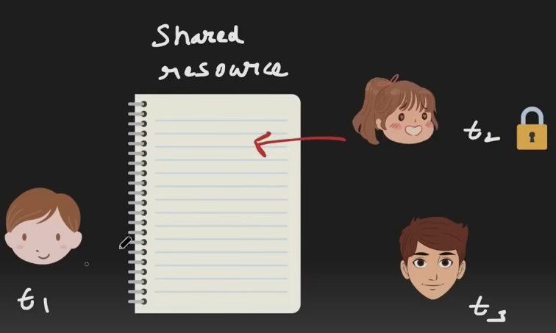

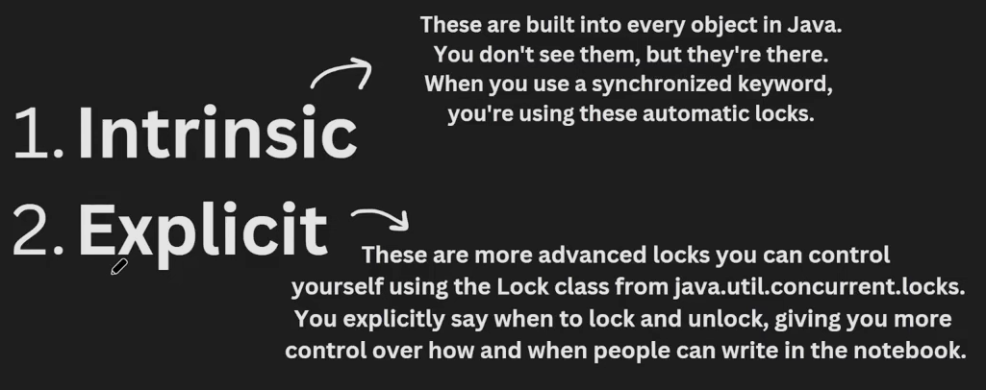

**Synchronized** – when a method is declared with synchronized keyword it means this method will acquire the intrinsic lock of the object the method belongs to.

Issue with intrinsic lock is that suppose t1 is running and it puts a lock and it gets stuck due to infinite loop, then other threads attempting to acquire the same lock will be **blocked indefinitely**. Explicit locking can solve it.

Lock is interface and ReentranLock is its impl class.

Lock.lock() 🡪 thread will wait for acquiring lock in BLOCKED state, just like synchronized.

.tryLock() 🡪 Acquires the lock if it is available and returns immediately with the value true. If the lock is not available then this method will return immediately with the value false.

.tryLock(**1000,** TimeUnit.*MILLISECONDS*) 🡪 Acquires the lock if it is free within the given waiting time and the current thread has not been interrupted. If the lock is available this method returns immediately with the value true.

.unlock 🡪 it is run by a thread which has already acquired a lock and now want to release it.

**Note :-** The reason why Sonar suggests to re-interrupt the thread is because by the time the exception occurs, the thread's interrupted state may have been cleared, so if the exception is not handled properly the fact that the thread was interrupted will be lost.

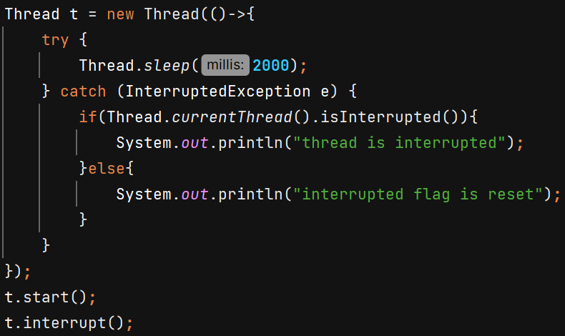 O/P – interrupted flag is reset

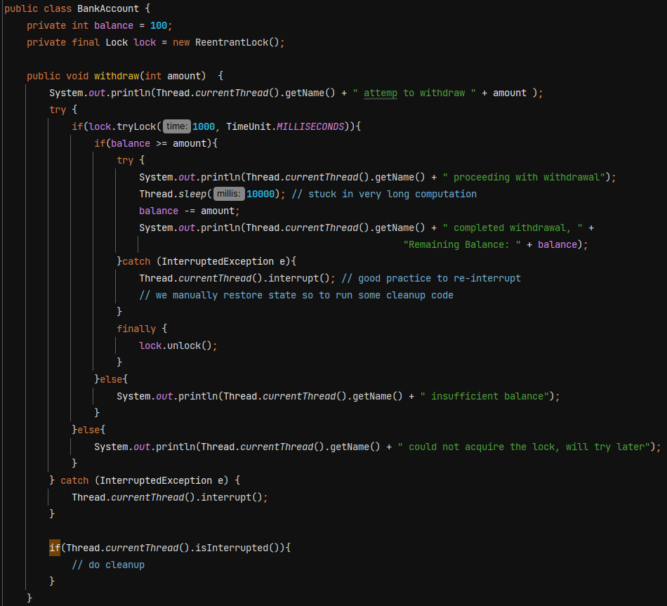

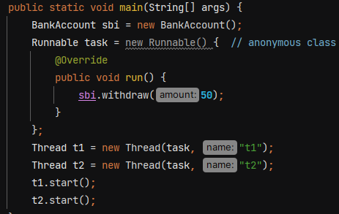

O/P - 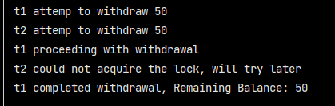

**Deadlock Prevention in ReentrantLock**

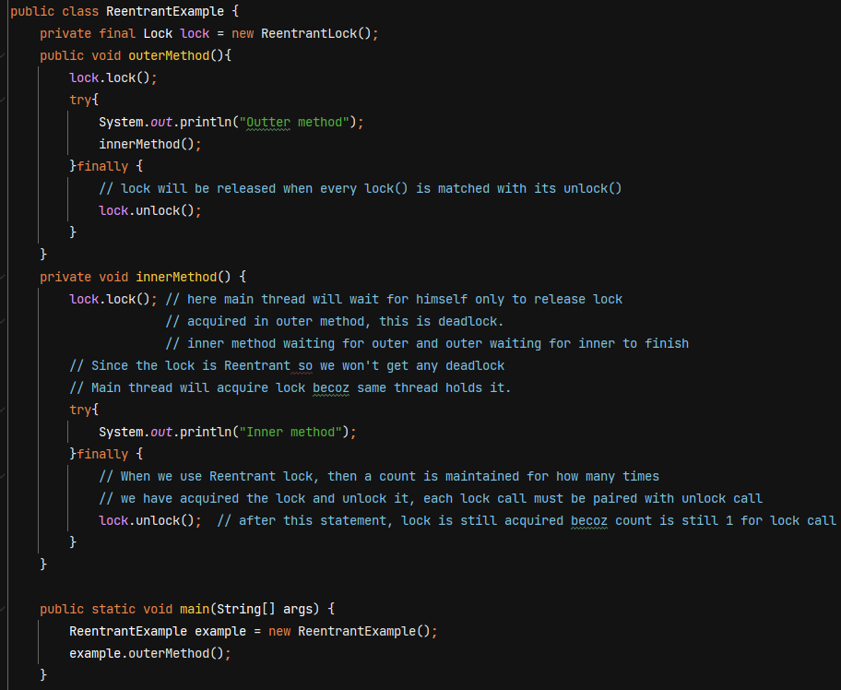

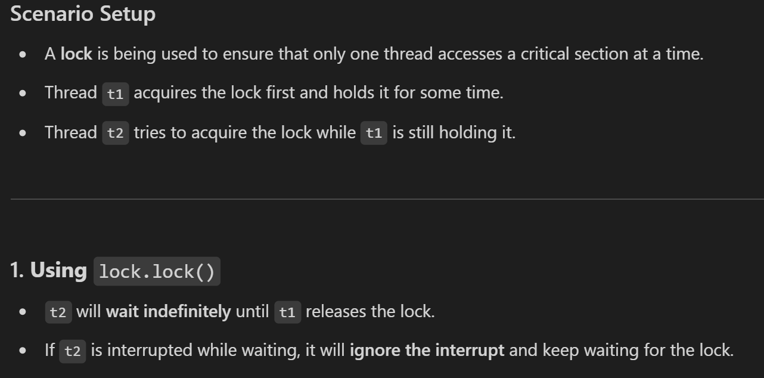

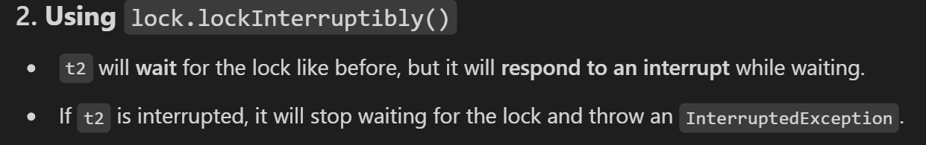

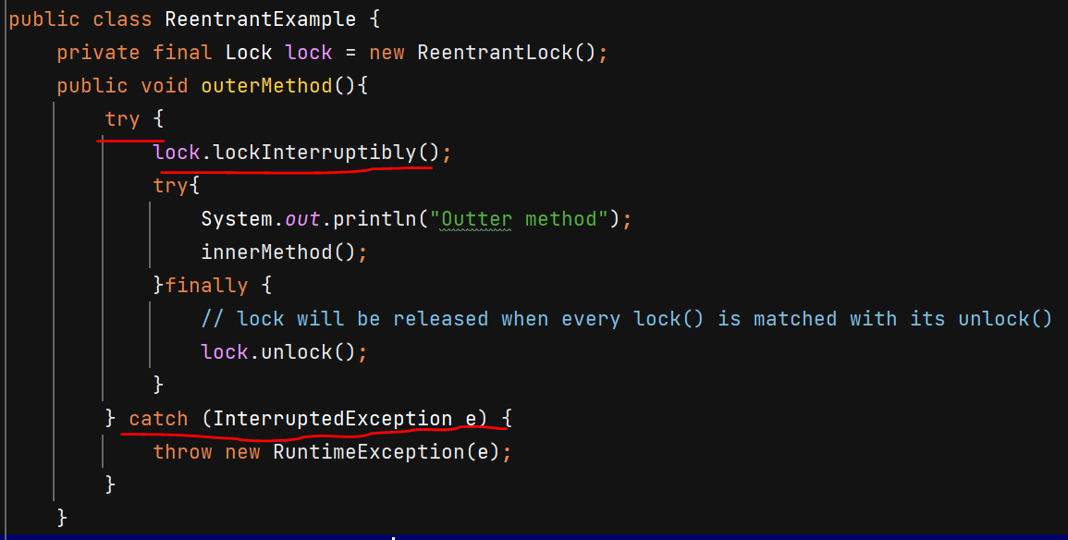

**Lock’s Fairness**

* A fair lock ensures that threads acquire the lock in the order they requested it  
  (i.e., a first-come, first-served basis)
* A thread will not starve (i.e., will not have to wait indefinitely) because threads that arrived earlier in the queue are guaranteed to get the lock before any new threads.
* A non-fair lock (when fairness is set to false) does not guarantee order

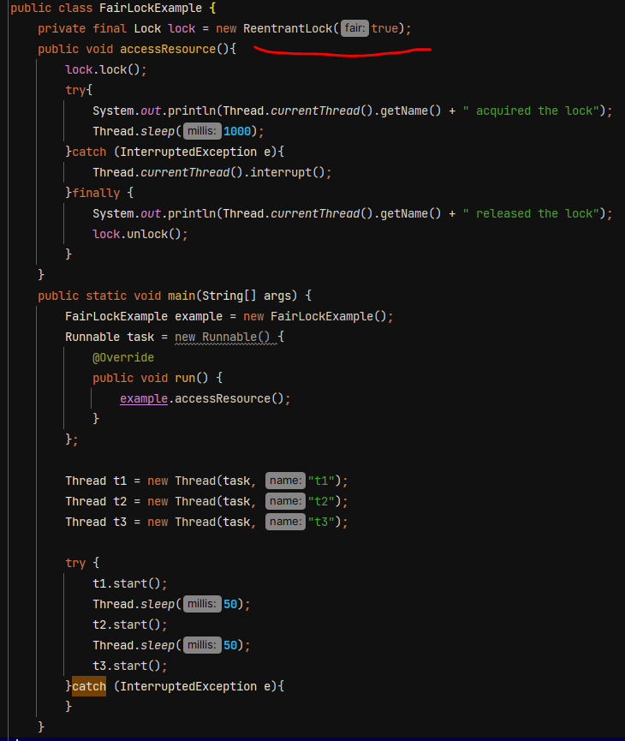

Problems with Synchronized –

* No fairness
* indefinitely blocking to acquire lock
* No Interruptibility
* No distinguish between read /write operations – synchronized will block every thread.

**ReadWriteLock** – it allow multiple threads to read resources concurrently as long as no thread is writing to it. It ensures exclusive access for write operations.

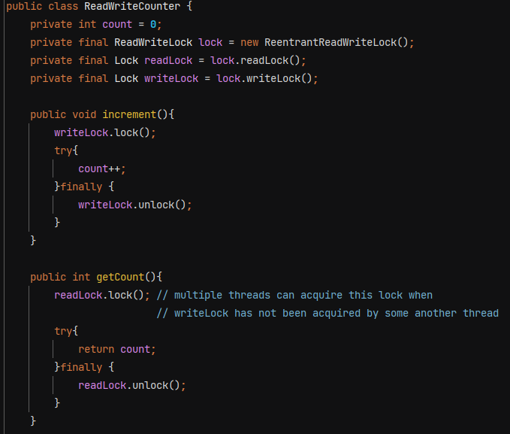

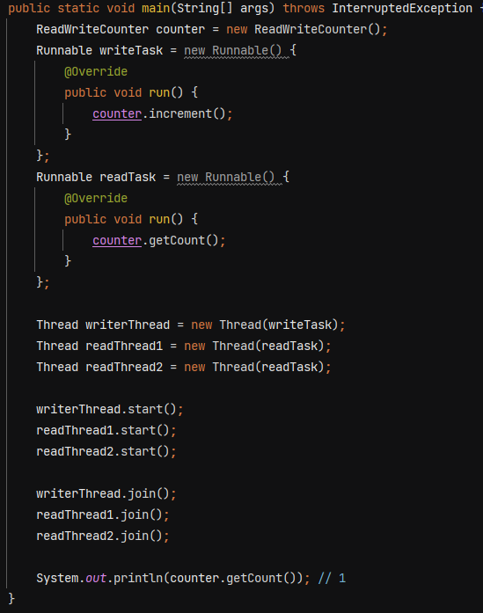

**Deadlock**

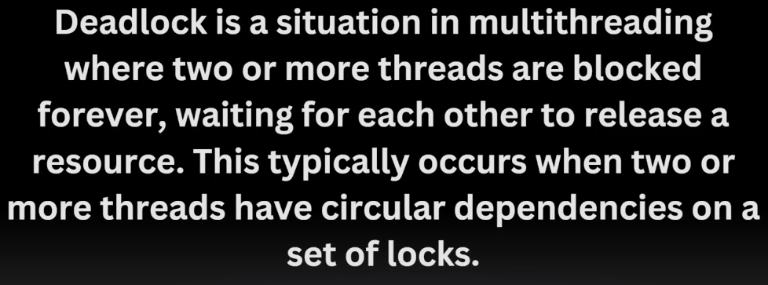

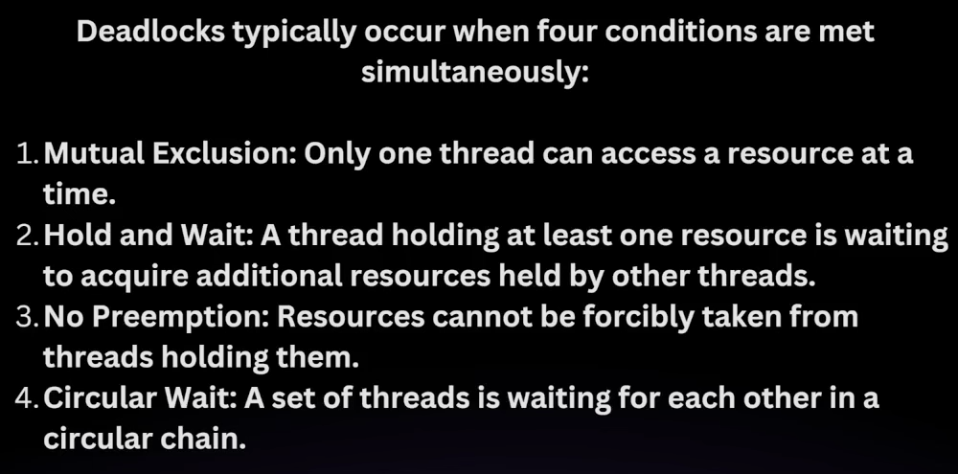

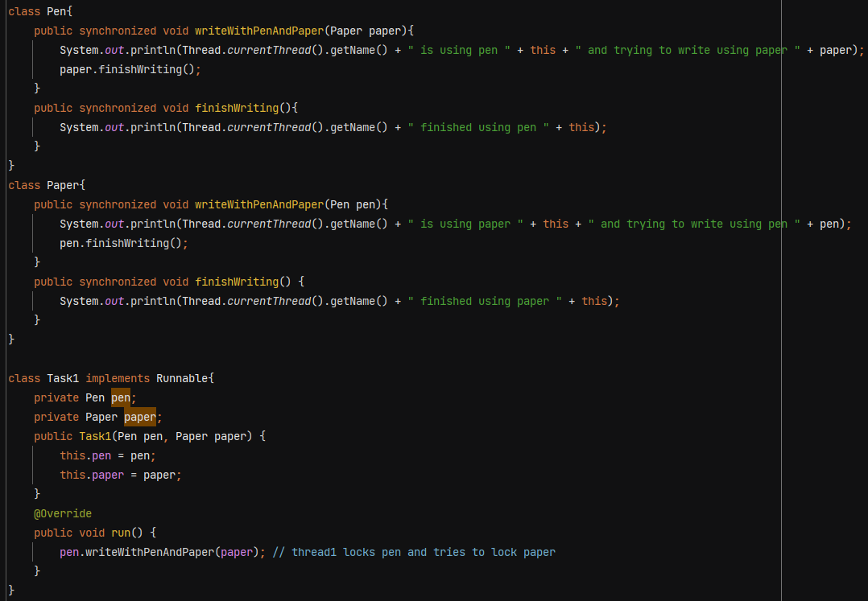

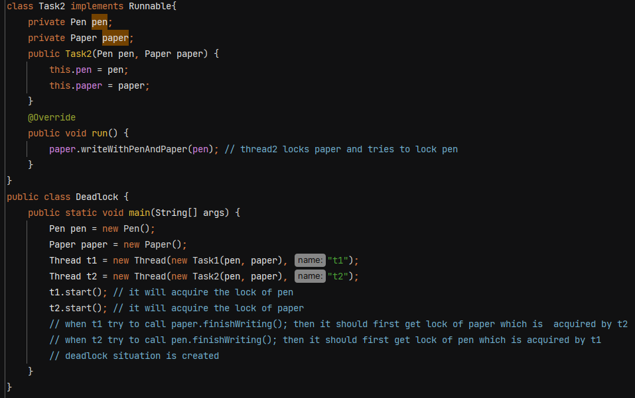

To avoid deadlock ensure that all the threads acquire locks in consistent order.

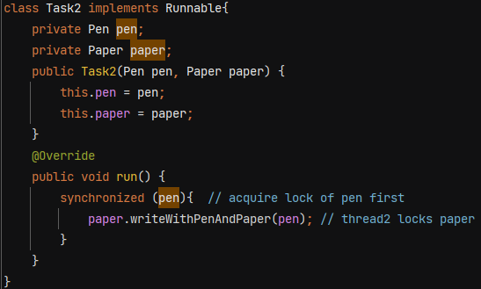 This will ensure that t2 will run only when it locks both pen and paper

**Thread Communication**

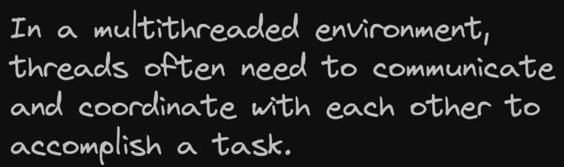

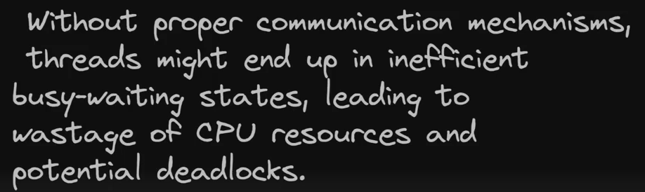

For thread communication, we have methods like wait(), notify() and notifyAll(). These methods can only be called within a synchronized context.

Wait() 🡪 tells current thread to release the lock and wait until some other thread run notify() or notifyAll()

Notify() 🡪 wakes up a single thread that is waiting

NofityAll() 🡪 wakes up all threads that are waiting

Ex-

We want Producer to produce data but wait if hasData is true. And Consumer should consume data when hasData is true.

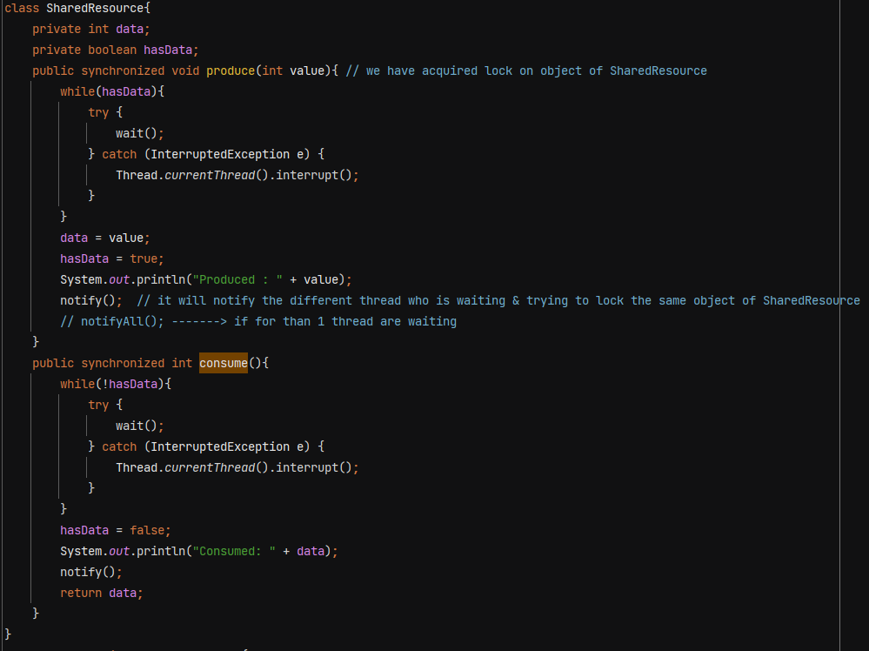

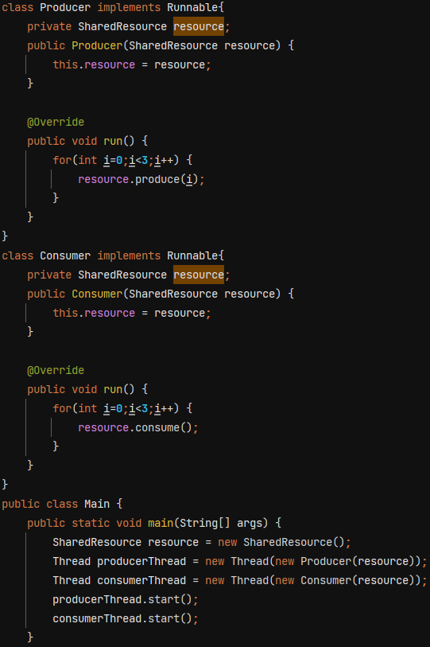

O/P - 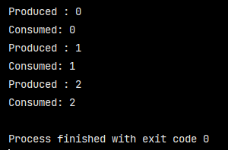

**Thread Safety** – a code is thread safe if it guarantee no unexpected results, no race condition when multiple threads try to access that piece of code with same object.

**Lambda Expression** – anonymous function

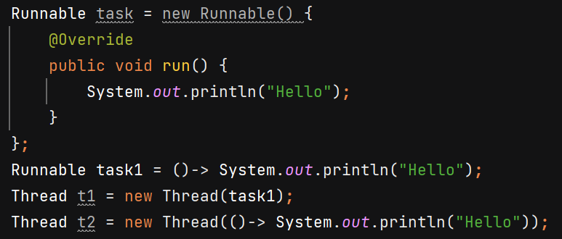

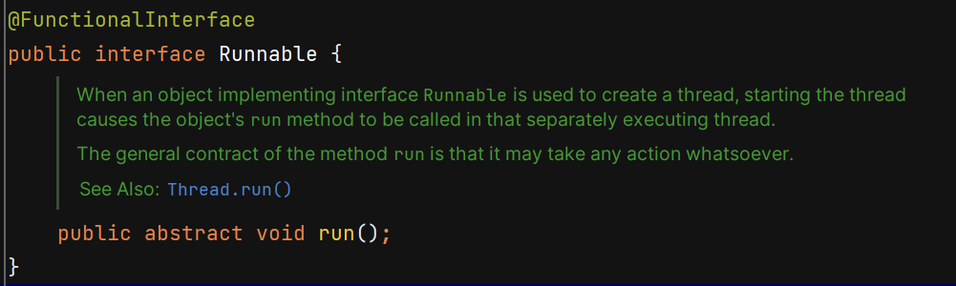 It does not return.

**Thread Pool** – collection of pre-initialised threads that are ready to perform a task.

Why ?

1. Resource management – every time creating and destroying threads is expensive.
2. Response time improves
3. Control over thread count – puts a limit o no of threads that can be created.

**Executors Framework**

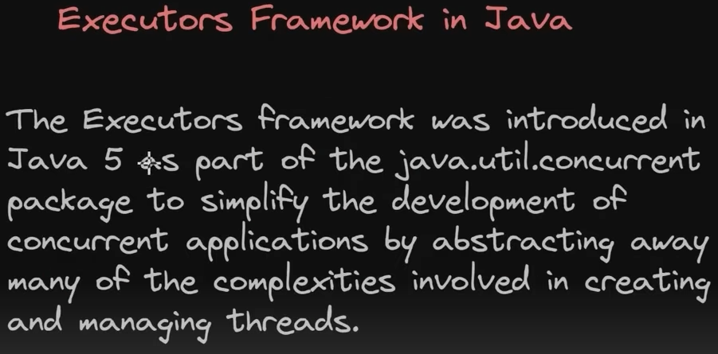

Problems prior to executor framework - 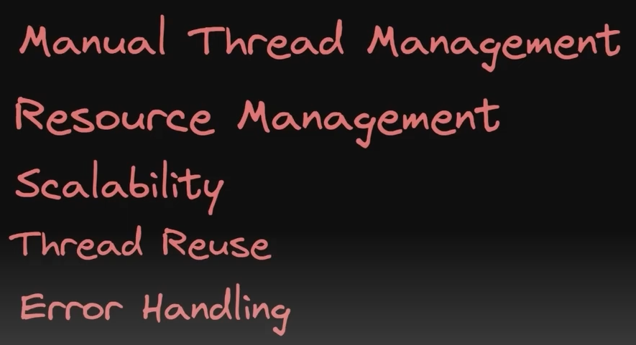

3 interfaces available – 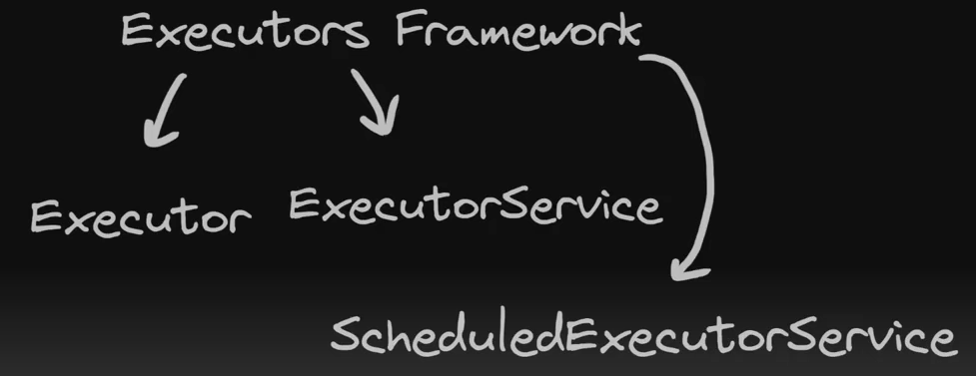

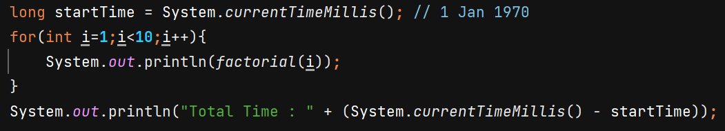

O/P- Total Time : 4575 ms

Using multithreading 🡺 O/P – 515 ms

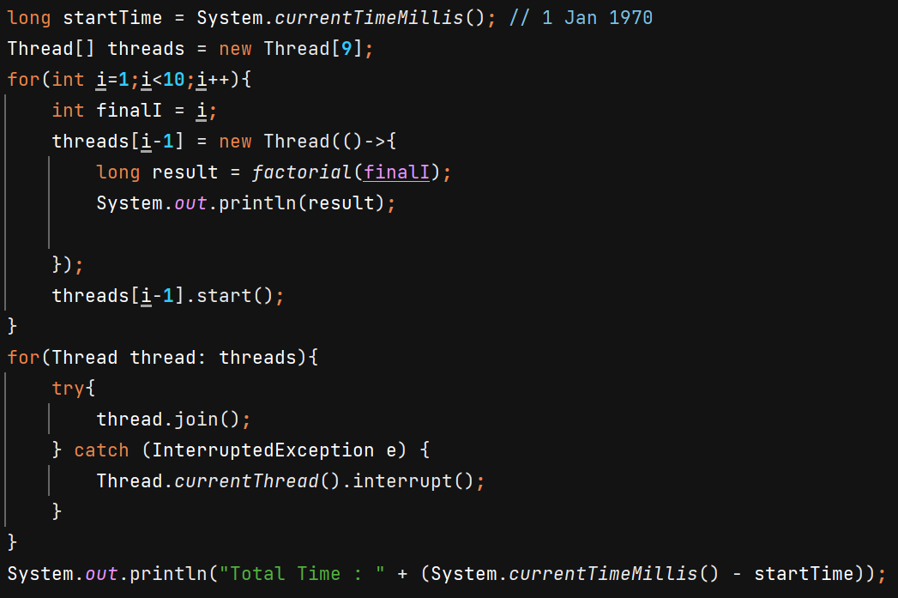

Using Executor Framework 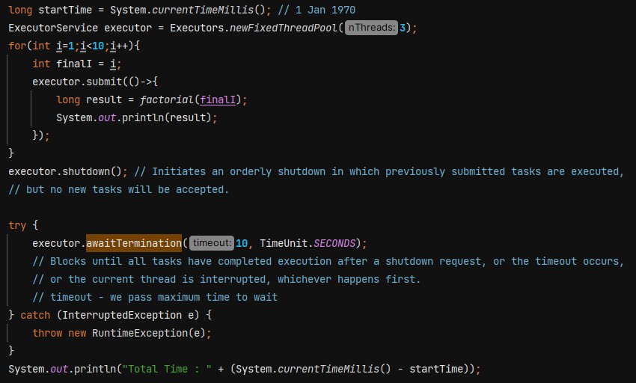

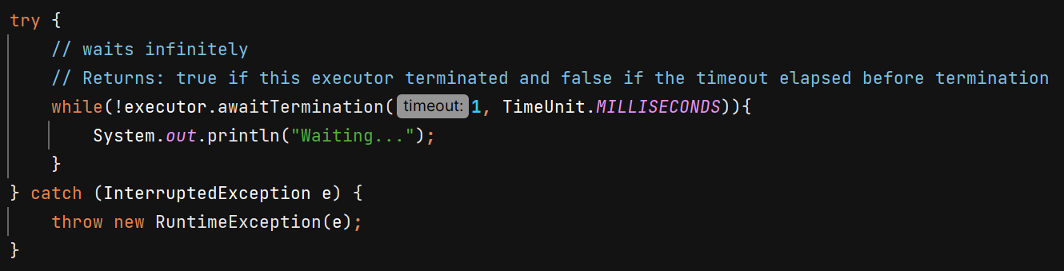

When you call submit(), the task is queued and will execute automatically if a thread from the pool is available. Calling shutdown() signals the executor to stop accepting new tasks and to complete the already submitted tasks, it does not block the current thread.



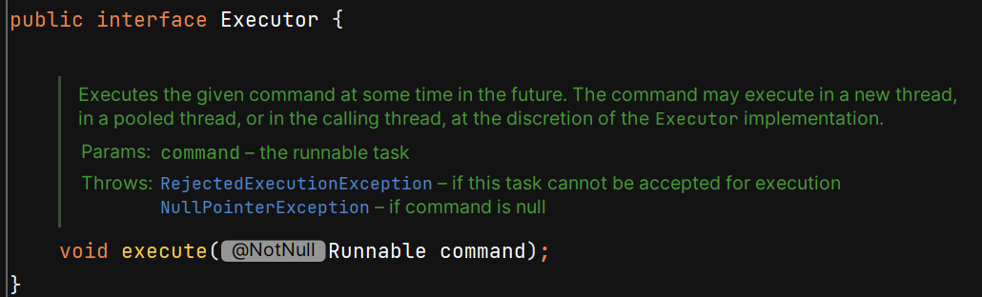

Executor does not contain methods like shutdown() so u need to manually do it. That’s why its useless. We’ll use ExecutorService becoz it provides more features.

Submit() method returns Future<T>

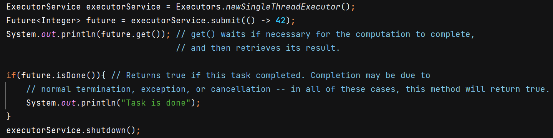

O/P - 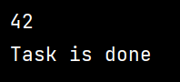

Submit() can take Runnable as well as Callable – 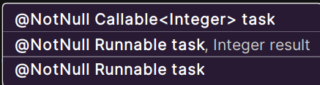

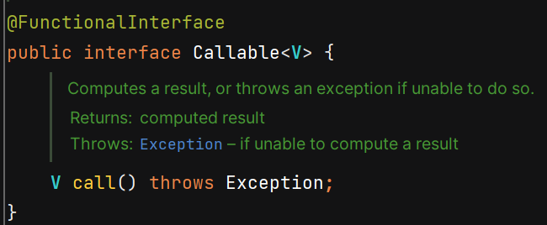 Callable returns value.

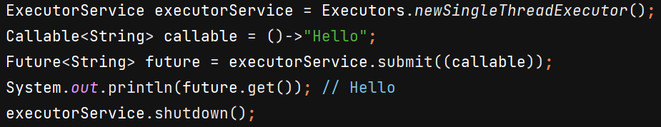

submit() method of Runnable argument is called -

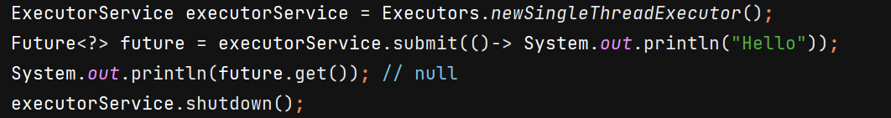

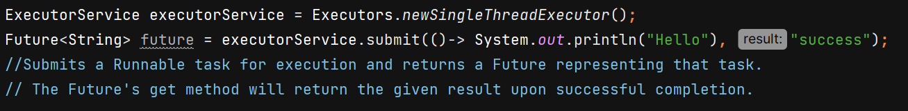

Difference - 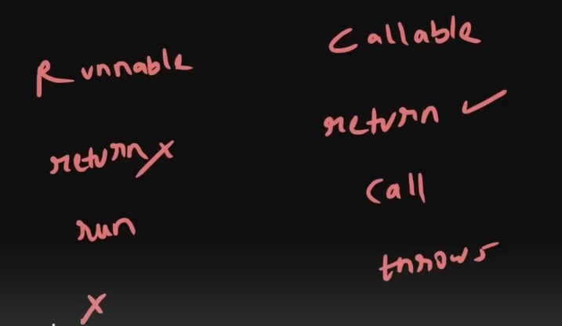

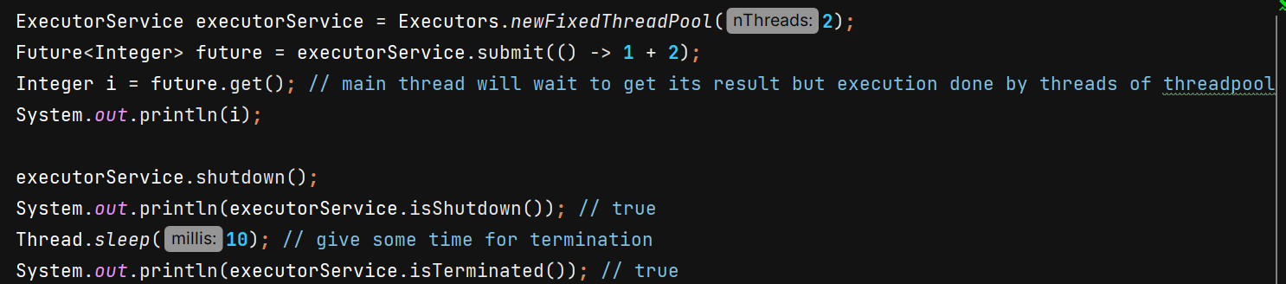

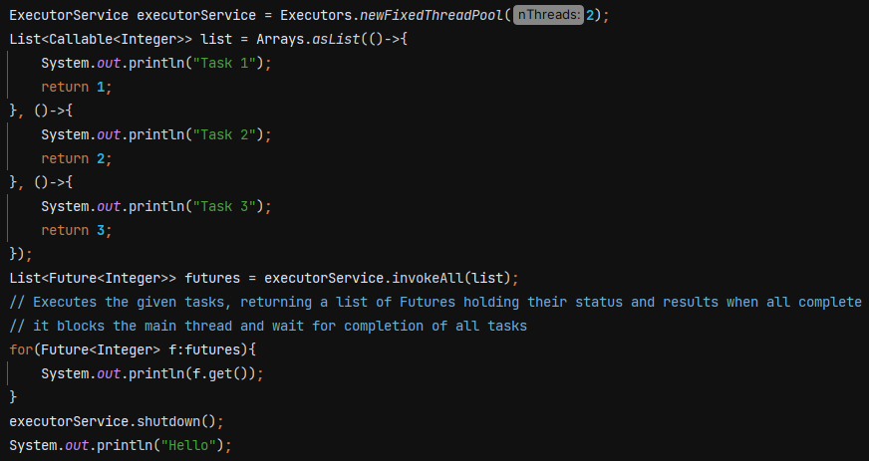

O/P 🡪 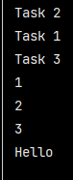

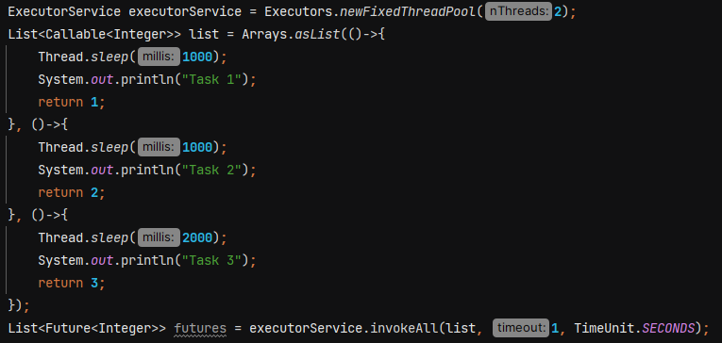

O/P 🡪 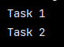

When we pass timeout in constructor, then it executes all the task which can be executed within time frame and other tasks are cancelled.

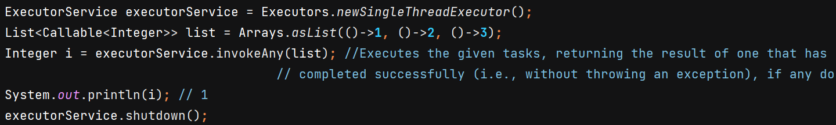

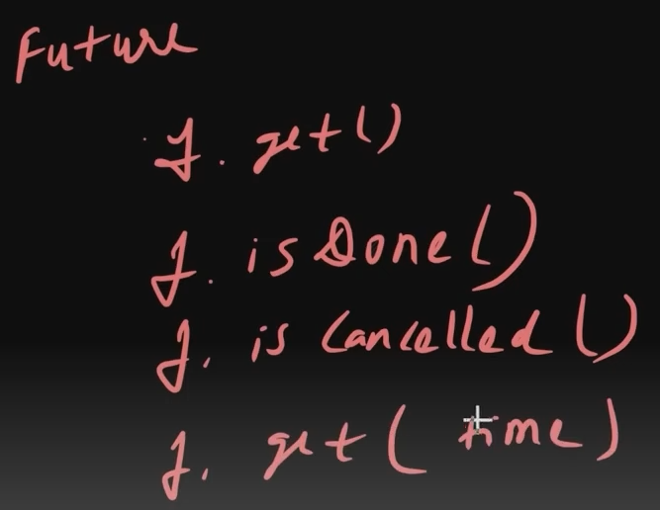

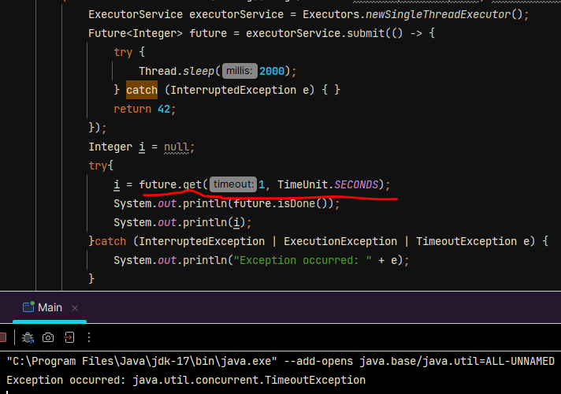

Explaination :- It waits for 1 sec, if task get completed then fine otherwise it gives TimeoutException.

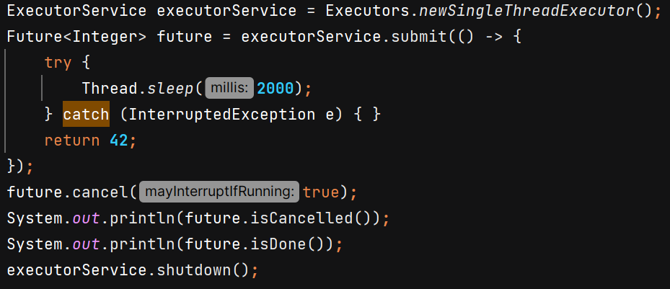

O/P 🡪 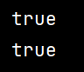

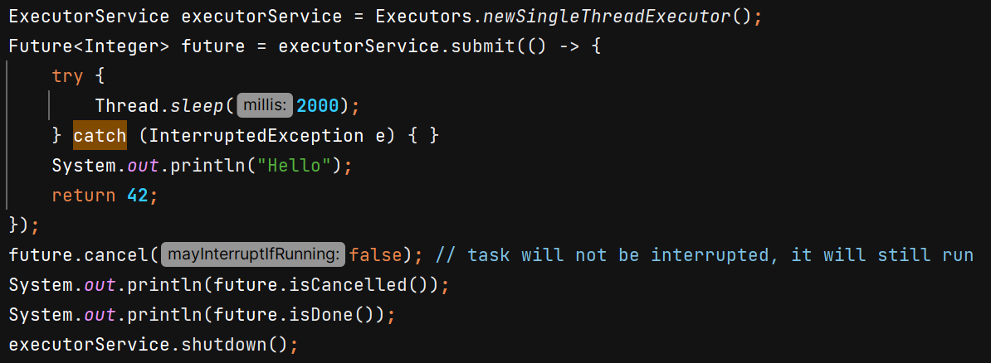

O/P 🡪 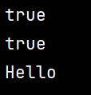

**Scheduled Executor Service** – used when we want something to run periodically.



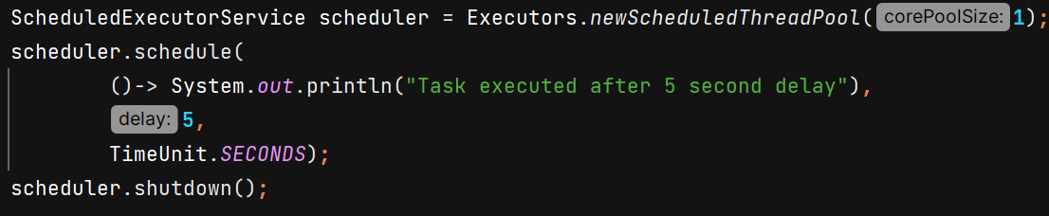

O/P 🡪 

On running .schedule() task will immediately go inside queue for execution and scheduler will wait for it to finish then shutdown.

But on running .scheduleAtFixedRate() it will not immediately come into queue. If scheduler.shutdown() is called **before the initial delay expires**, the scheduler will terminate immediately, and the task will never run. So we need to handle it properly –

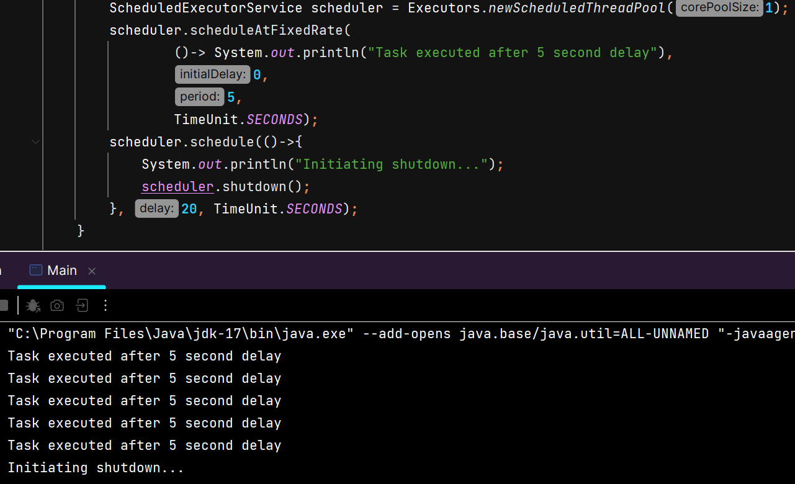

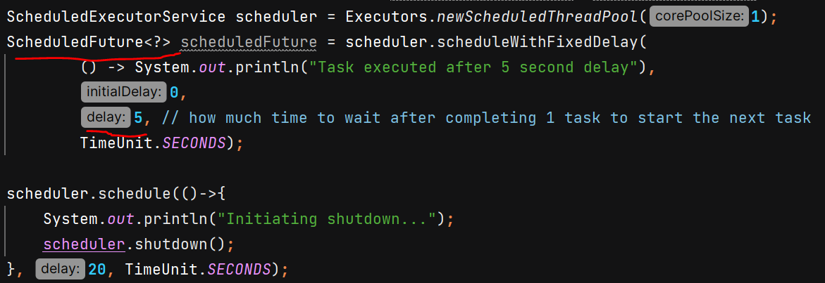

**Cached Thread Pool –** It creates a thread pool where it creates new threads as per need and terminates then after 60 seconds of inactivity. It dynamically adjusts the pool size. It is useful when load is variable and short lived. Do not use it when task are very time consuming.



**CountDownLatch** – It allows one or more threads to wait for a set of operations being performed by other threads to complete before proceeding further.

Ex- we want to achieve that our main thread wait for some other dependent services.

Without – 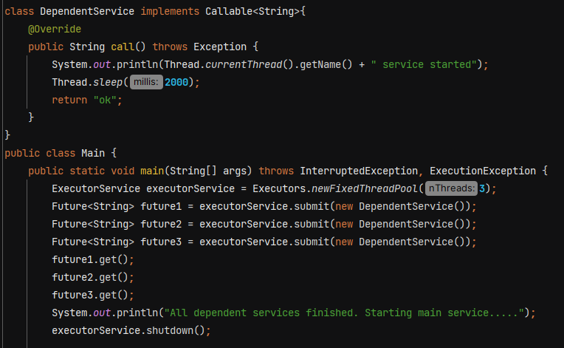

With CountDownLatch -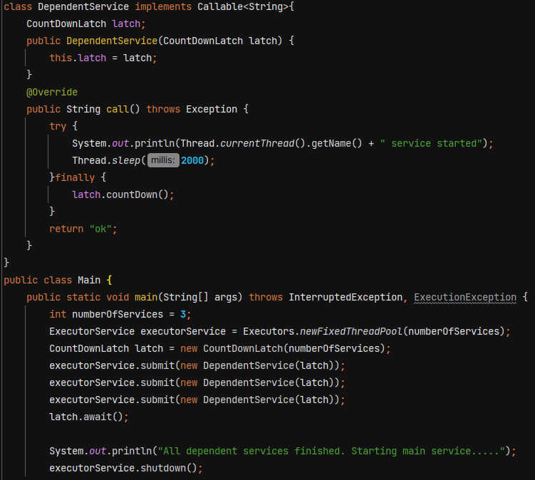

O/P 🡪 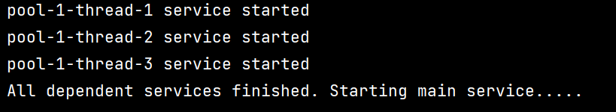

Using threads –

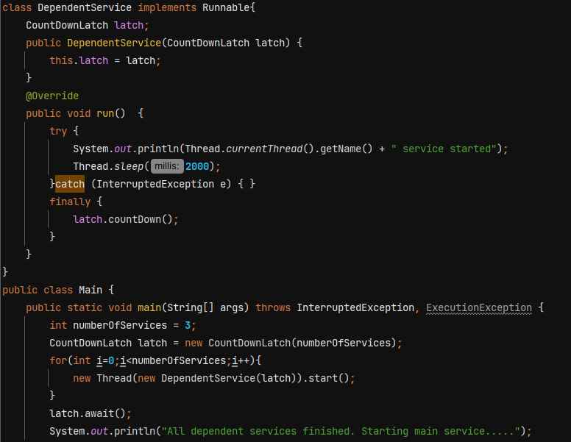

O/P 🡪 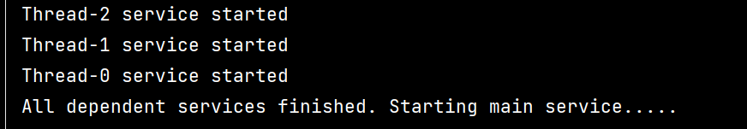

We can also pass timeout in await()

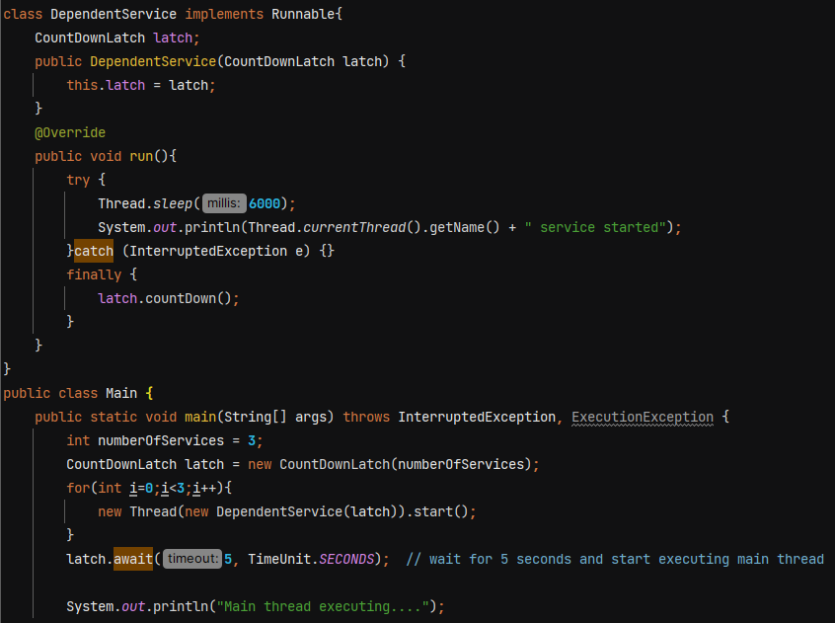

O/P 🡪 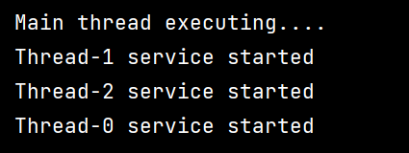

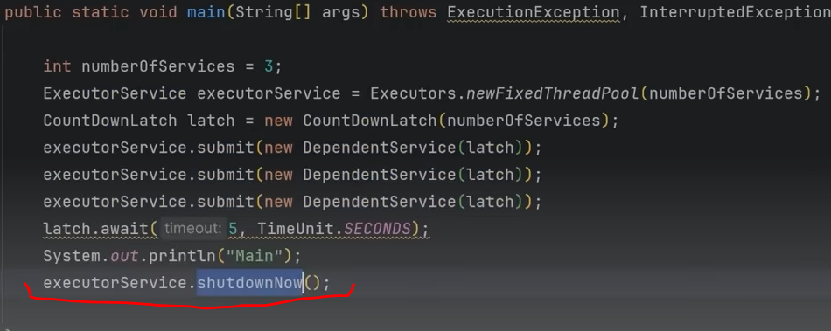

.shutdownNow() will terminate the worker threads immediately.

**CyclicBarrier** – It is reusable

CountDownLatch is not reusable, once the count reaches 0 it cannot be reset.

In cyclic barrier, multiple threads wait at a point until all threads reached at that point. When the last thread reaches the barrier then all threads are released. It does not block main thread. It is used to make sure that certain no of threads reach at a particular point before any of them proceed.

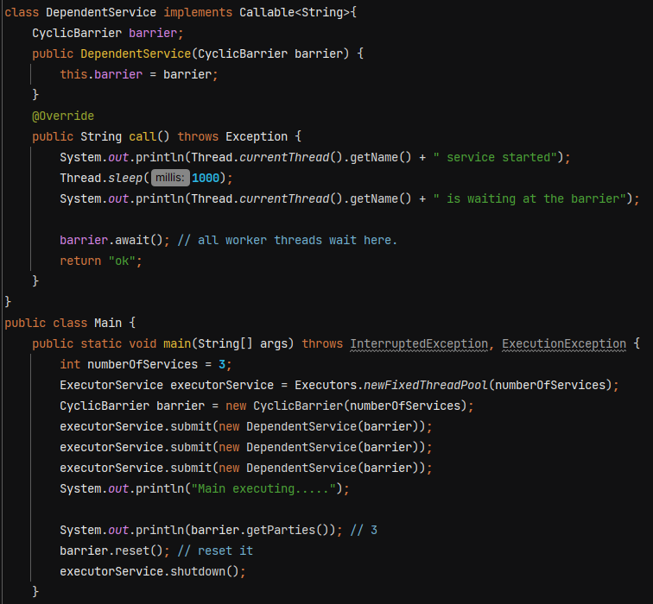

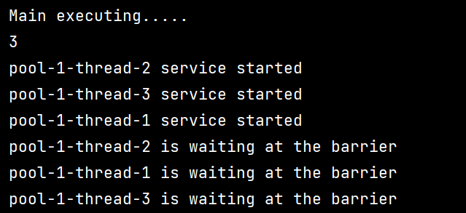

Ex- image a big application having multiple subsystem

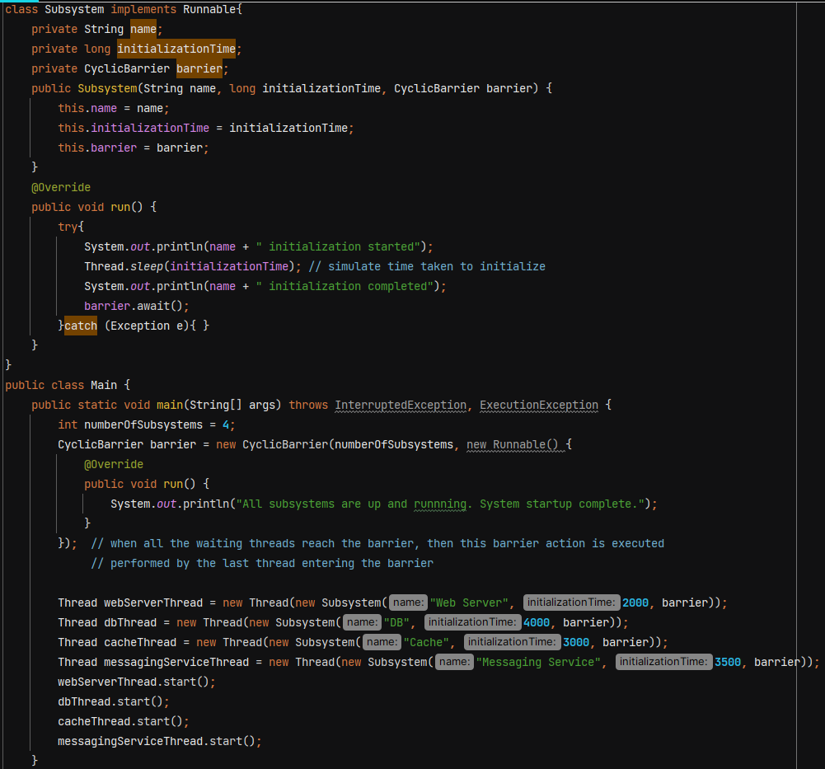

O/P 🡪 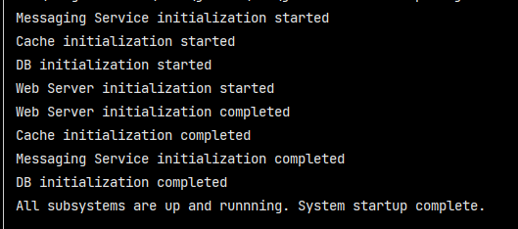

**CompletableFuture**

Introduced in JAVA 8 to handle asynchronous programming

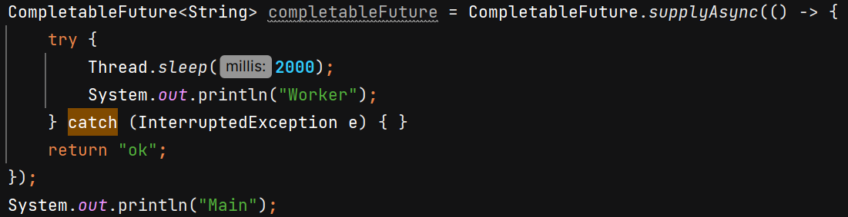

O/P 🡪 

we don’t see sout of “Worker” because CompletableFuture uses daemon thread.

If we want to run the task –

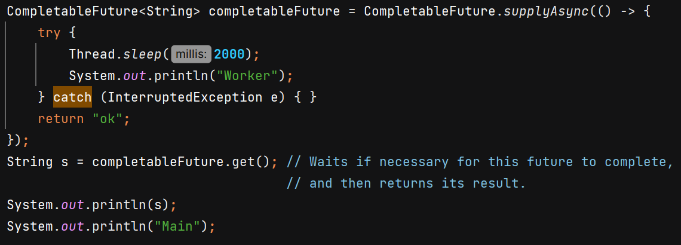

O/P 🡪 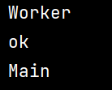

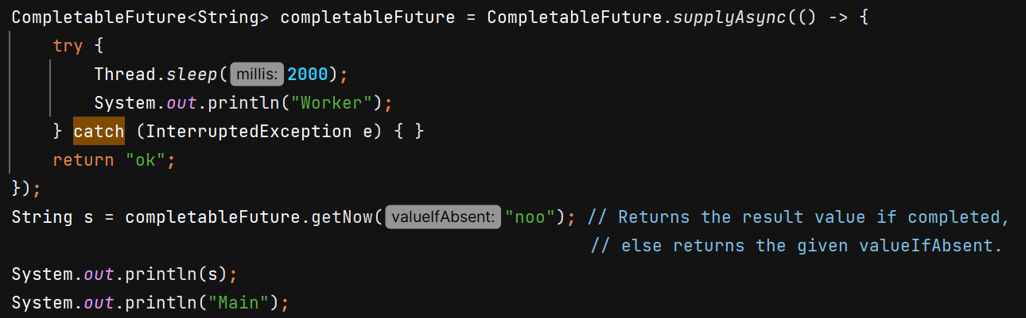

O/P 🡪 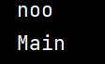

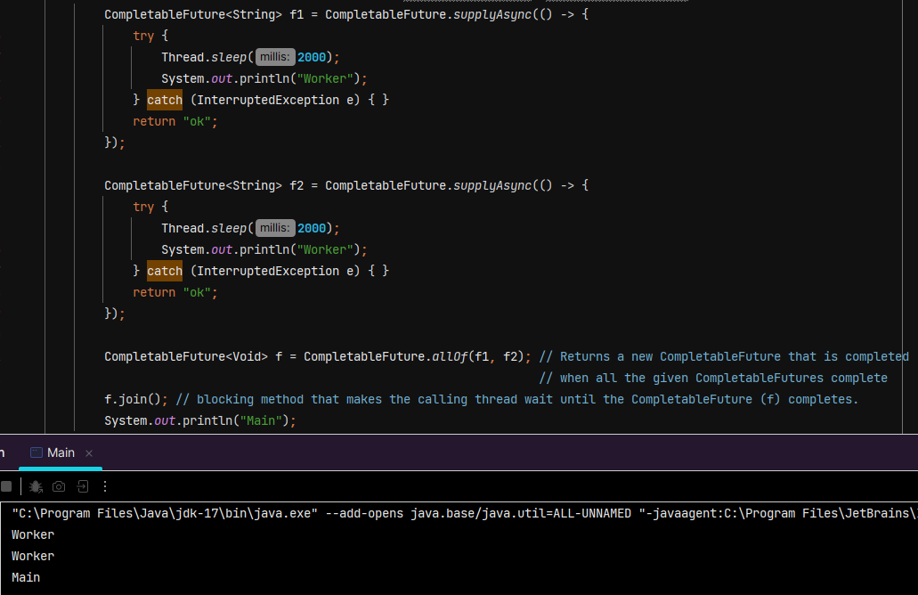

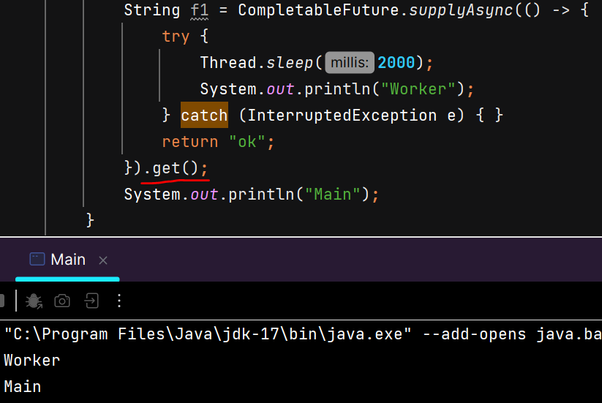

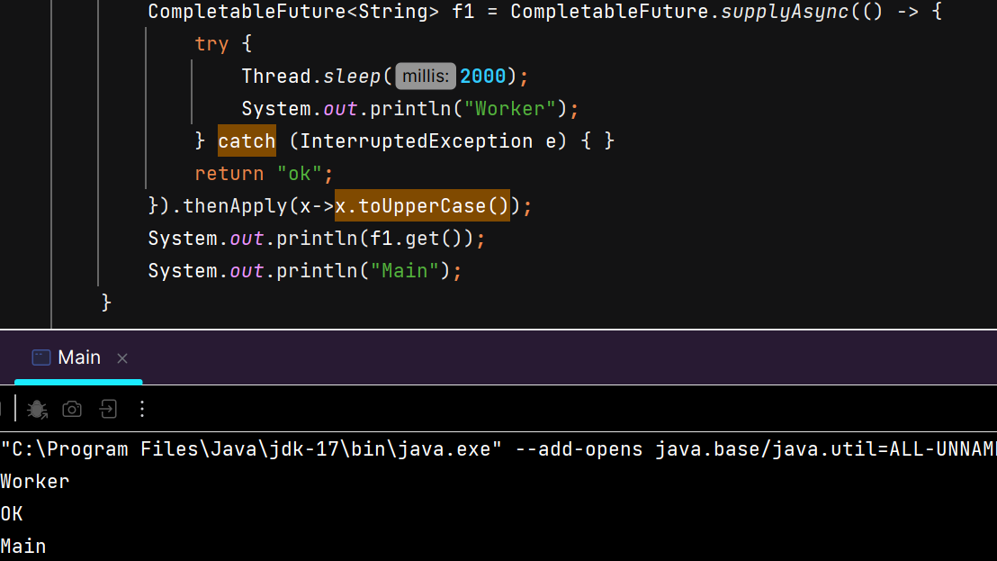

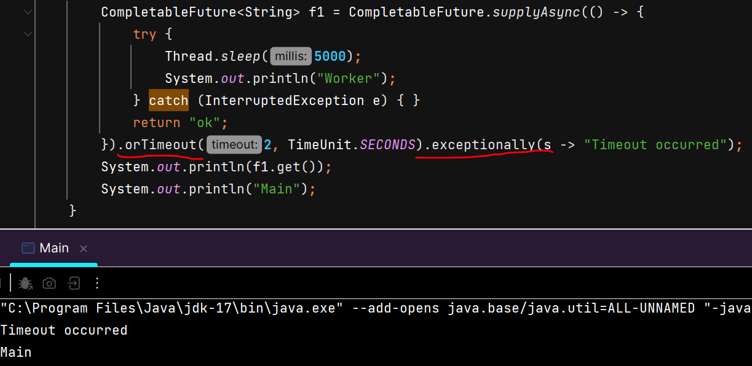

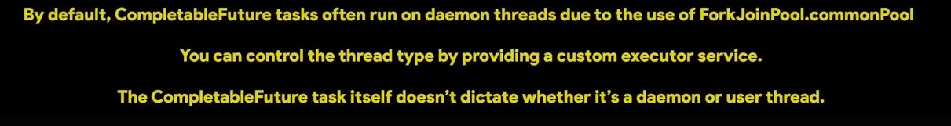

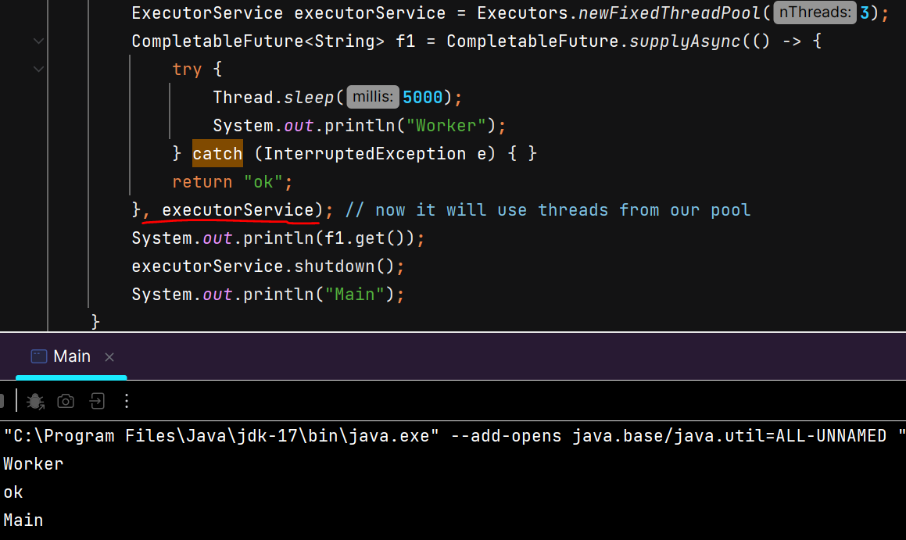

**Volatile vs Atomic**

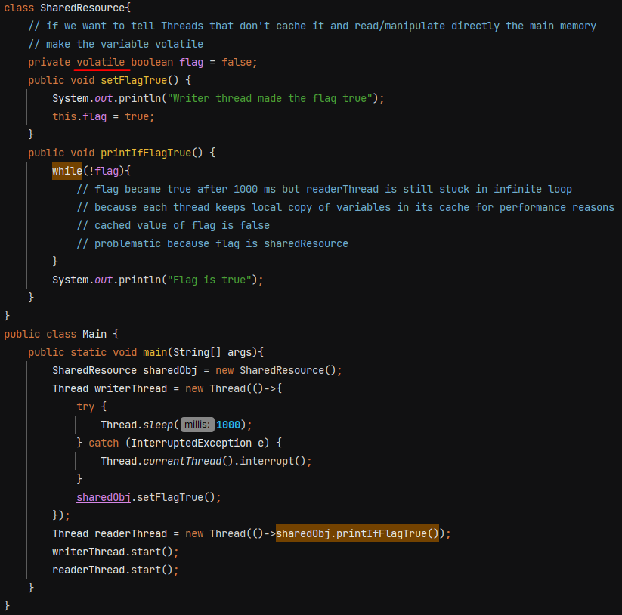

If we don’t make variable volatile then readerThread is stuck in infinite loop. But in complex scenarios it also has disadvantages as there is no thread safety.

AtomicInteger, AtomicLong, AtomicBoolean - does not use locks. It achieves thread safety using **non-blocking, lock-free algorithms** that rely on **low-level hardware support** for atomic operations.

